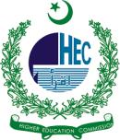
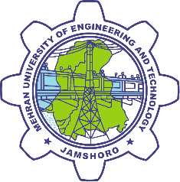

SOCIAL INTREGRATION & OUTREACH PROGRAM

MEHRAN UNIVERSITY OF ENGINERING & TECHNOLOGY AND HIGHER EDUCATION COMMISION, PAKISTAN

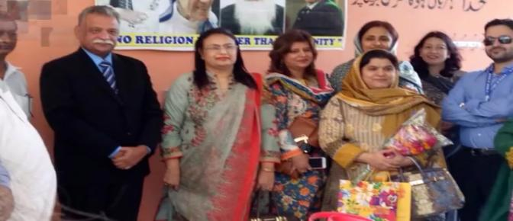

SIOP PROJECT REPORT
MESSAGE FROM THE VICE CHANCELLOR

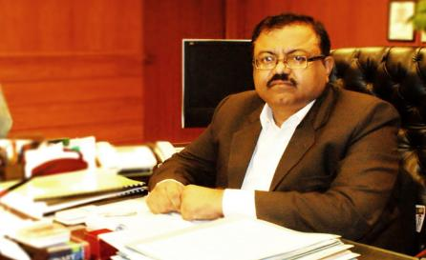

Mehran UET has the honor of being selected by Higher Education Commission (HEC) project for Social Integration Outreach Program (SIOP) .Mehran University believes in providing service to the community and has been doing through various initiatives. The selected project embodies some of the issues dear to my University. i.e Gender Equity (MUET in 1ST Public sector University to have approves Gender Policy).Sustainable Development Goals (the university has already commenced the transition towards renewable energy and the USPAS-Water Center is working on providing clean drinking water solution. And creating responsible citizens for which the university won the 2017 CSR Award.
Our dedicated team under took this project with zeal for its successful completion .The University provided financial as well as technical assistance for achieving the project goals .The project has proven to be low-cost and broad impact covering Jamshoro, Kotri, Hyderabad. I believe that the project will certainly help in empowering the women in the field of education for Sustainable development as mandated by UNESCO. And provide them clean water and clean energy awareness. Such project should be encouraged in future and kudos to HEC for this initiatives. Mehran University would always support actions that benefit Girls education and SDGs.

Prof. Dr. Mohammad Aslam Uqaili
Vice Chancellor, Mehran UET
Patron of Society of Women Engineers affiliate
TABLE OF CONTENT

S.NO# | CONTENT
1 | MESSAGE FROM VC
2 | MESSAGE FROM MENTOR
3 | ABBREVIATIONS
4 | EXECUTIVE SYMMARY
5 | 1 BACKGROUND OF SIOP
6 | 1.1 MILLINIUM DEVELOPMENT GOALS
7 | 1.2 SUSTAINABLITY DEVELOMENT GOALS
8 | 1.3 CHALLENGE
9 | 1.4 SOCIETY OF WOMEN ENGINEERS
10 | 1.5 STEM
11 | 1.6 GENDER EQUALITY
12 | 1.7 REGION
13 | 2 PROJECT
14 | 2.1 OBJECIVES OF SIOP
15 | 2.2 STRATEGY &PROGRAM FOCUS
16 | 2.3 LIMITATIONS
18 | 3 PROJECT ACTIVITIES
19 | 3.1 IDENTIFYING SCHOOLS
20 | 3.2 TRAINING OF TRAINERS (TOT)
21 | 3.3 MONITORING KNOWLEDGE TRANSFER
22 | 3.4 PRACTICAL IMPLEMENTATION
23 | 3.5 STUDENT PROJECTS AND PRESENTATIONS
24 | 3.6 CELEBRATING SUCCESS
25 | 3.7 WAY FORWARD
26 | 3.8 MESSAGES

ABBREVRATIONS

SIOP:  HEC:  HEI’S  MUET:  SWE:  SDG’s:  MDG’s:  ESD:  BCFD:  UN:  UNDP:  UNICEF:  USAID:  STEM:  WEF’S:  ASER:  GPI:  ToT  IT:  LED: | Social Integration Outreach Program  Higher Education Commission  Higher Education Institutes  Mehran University OF Engineering and Technology  Society of Women Engineers  Sustainable Development Goals  Millennium Development Goals  Education for Sustainable Development  Billion Cubic Feet Per Day  United Nations  United Nations Development Program  United Nations International Children's Emergency Fund  United States Agency for International Development  Science, Technology, Engineering and Mathematics  World Economic Forum's  Agency for the Cooperation of Energy Regulators (EU)  Gender Parity Index  Training of trainers  Information Technology  Light Emitting Diode

EXECUTIVE SUMMARY

SOCIAL INTEGRATION OUTREACH PROGRAM (SIOP)
“HOLDING HANDS”
The United Nations declared the decade from 2005 to 2014 the ‘UN Decade of Education for Sustainable Development’. The 17 SDGs announced in Paris COP21 in December 2015 have laid particular emphasis on sustainable education, water and energy. As environmental concerns grow in our societies, Academia, Government and Communities are increasingly attentive to sustainable practices and ethics. Having developed a strong presence in the region, MUET aims to develop responsible and proactive relationships with all its stakeholders. MUET in partnership with the HEC and Uspcas-w has implemented the 'Social Integration & Outreach Program' 2016. Under this program, the University reached out to Girl's High-Schools and Colleges for imparting UNESCO's Education for Sustainable Development. About 30 schools were visited and selected 5 neighboring schools - Zubaida Govt Degree Girls College, Hyderabad - Govt Degree Girls College, Kotri - Govt Girls Higher Secondary School, Jamshoro - Mehran Public Higher Secondary School, Jamshoro - Govt Girls College, Qasimabad and targeted students in 11th and 12th grades. University’s dedicated team developed the training curriculum and conducted preparatory meetings with management of schools. University conducted ToT of nominated school faculty with partnering university faculty on Clean Water, Clean Energy and Active Citizen Program delivered by Ms. Shabnam Baloch, Zulfiqar Ali Umrani and Abdul Bari Noonari respectively. Subsequently, trained trainers carried out training of students and encouraged those to develop SDGs based projects of which selected projects were financed and implemented. The equipment required fund of per pilot project was about Rs 40,000. Also small funds were allocated for implementation of selected student lead projects. The total budget for the project got 10 million by HEC and MUET for the Project completion under the limited time period of four months. The society of women engineering (SWE) actively participated to complete this project. This program of MUET has been highly appreciated by the international and country heads from the UN, UNDP, UNESCO, UNICEF, and EU. The ESD trainings imparted to the faculty and students shall have direct impact on the common man, society and environment by bringing their new knowledge to their homes and benefit from decreased electricity and water bills. The projects developed by students shall introduce innovative actions in the community. The awareness of SDGs shall be highly beneficial for the community in the long run to shape responsible citizens.
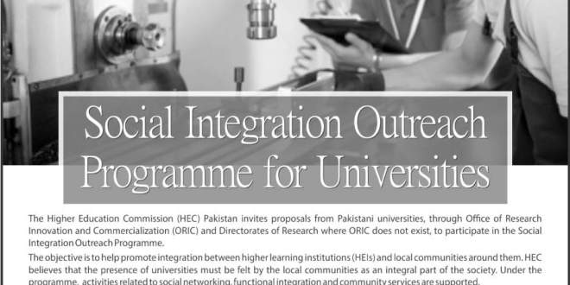

1 BACKGROUND

Pakistan is facing grave energy shortage with frequent power outages. The average shortfall in the power sector is 4,000 Mega Watts, and nearly two billion cubic feet per day (BCFD) in the natural gas sector. The shortfall in the power sector can rise to around 7,000MW or 32pc of total demand for electricity Chronic power shortage, in the form of load-shedding and power outages, coasted the Pakistan economy Rs14 billion (7pc of GDP) last year. Over 140 million Pakistanis either have no access to the power grid or suffer over 12 hours of load-shedding daily. Pakistanis who do not have access to the grid are often poorer than those on the grid. Meanwhile, household electricity consumption has grown at an average annual rate of 10pc yearly.
Burning fossil fuels is having adverse effect on our climate. This Climate Change is highly detrimental to our nation, in particular to vulnerable communities in our region. According to United

Nation Environmental Program report, Pakistan shall soon be a highly Water-Stressed country. Both, Energy and Water and very precious resources and we need to use them responsibly .A more immediate solution to the problem is the conservation and efficient use of energy, as about 67pc of domestic energy consumption stems from inefficient appliances such as lights and fans. Another alternative is to shift to renewable forms of energy, such as wind and solar power. There is enough potential from wind generation to supply all of Pakistan's electricity needs. Half this potential exists in one contiguous belt of Sindh coastline. There are around 1.2m irrigation pumps installed in Pakistan, with about 90pc of these pumps using diesel directly or indirectly. The use of solar irrigation pumps for agricultural purposes instead of diesel-powered or tractor driven pumps could mean a 27pc saving in consumption of diesel fuel for irrigation pumping. In order to encourage Water conservation and Energy Efficiency, we need to develop behavioral change in our society. This is the first step to take this Education for Sustainable Development from Universities to Schools. Social Integration & Outreach Program’ was develop by Mehran University of Engineering & Technology, in collaboration with the Higher Education Commission. holding hands was the theme of the HEC Social Integration outreach program (SIOP)and propose of this program was to reach out their surrounding school and collages and to empower women and facility them to get education and the aiming goals was SDG 6 and SDG7 clean energy and clean water. The time duration of this project was 4 month and budget for the project was 10 million. 5 million from HEC & 5 million from MUET the society of women engineering (SWE) was actively participating to complete this project.
Mehran University of Engineering & Technology (MUET), Jamshoro is an important Higher Education Institute in the region. Through its policies in education and implementation, the University had fully embraced the United Nation’s Sustainable Development Goals (SDGs) for socio-economic development of the region. Continuing this trend, the University wishes to reach out to its surrounding schools/colleges to impart Education for Sustainable Development (ESD). ESD empowers children, adolescents and adults to shape their mindset and actions for a sustainable future. We must be aware that our actions today will have an impact on the lives and freedoms of future generations and people in other parts of the world. It conveys the values that form the basis of sustainable development and underlines the complexity and interdependence of three spheres, the environment, society and the economy.

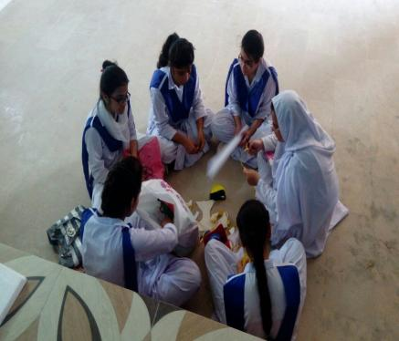
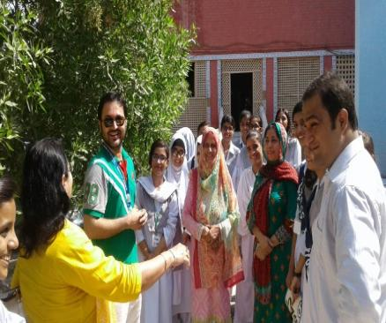
“Students preparing various project”
“MUET team interacting with school/college management team”

1.1 SUSTAINABLE DEVELOPMENT AGENDA

MDGs

The Millennium Development Goals (MDGs) showing uneven progress, this review identifies possible limitations arising from the MDG framework itself rather than extrinsic issues. MDGs as being created by only a few stakeholders without adequate involvement by developing countries and overlooking development objectives previously agreed upon. Others claim MDGs are unachievable and simplistic, not adapted to national needs, do not specify accountable parties and reinforce vertical interventions. Pakistan got little progress on MDGs.
SDGs

In 2015, countries adopted the 2030 Agenda for Sustainable Development and its 17 Sustainable Development Goals. The SDGs build on the MDGs anti-poverty targets that the world committed to Achieving by 2015. The MDGs, adopted in 2000, Aimed at an array of issues that included slashing poverty, hunger, disease, gender inequality, and

Access to water and sanitation. Despite this success, the indignity of poverty has not been ended for all. That is why the world came up with the new Global Goals and the broader sustainability agenda, which go much further than the MDGs, addressing the root causes of poverty and the universal need for development that works for all people.
The Global Goals will now finish the job of the MDGs and ensure that no one is left behind. The SDGs work in the spirit of partnership and pragmatism to make the right choices now to improve life, in a sustainable way, for future generations. They provide clear guidelines and targets for all countries to adopt in accordance with their own priorities and the environmental challenges of the world at large scale. SDGs, otherwise known as Global Goals, are also regarded as 2030 Agenda for Sustainable Development.

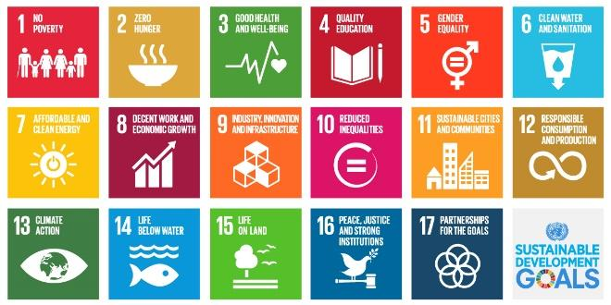

“Sustainable development goals”
1.2 CHALLENGES

- Around the Pakistan nearly 60% girls are not in school. Globally, 1 in 3 women will experience gender-based violence in her lifetime. In the developing world, 1 in 7 girls is married before her 15th birthday, with some child brides as young as 8 or 9. Each year more than 287,000 women, 99 percent of them in developing countries, die from pregnancy- and childbirth-related complications.
- While women make up more than 40 percent of the agriculture labor force only 3 to 20 percent are landholders. In Asia, that number is only 3 percent. And despite representing half the global population, women comprise less than 20 percent of the world's legislators
- And the girls which are enrolled in schools are not getting proper facilities like clean water, energy and other social issues there is no water facility and many schools has no electricity due to load shedding and due to unhygienic condition they become ill..
- It is becoming increasingly difficult to discuss the challenges that Pakistani women face at all.

1.3 SOCIETY OF WOMEN ENGINEERING

For more than six decades, SWE has given women engineers a unique place and voice within the engineering industry. SWE is centered on a passion for our Members success and continues to evolve with the challenges and opportunities reflected in today's exciting engineering and technology specialties.
SWE MUET
SWE MISSION

“Stimulate women to achieve full potential in careers as engineers and leaders, expand the image of the engineering profession as a positive force in improving the quality of life, and demonstrate the value of diversity”.
part of a global initiative which is a worldwide not-revenue driven instructive and administration association. SWE is the main thrust that sets up designing as an exceptionally attractive profession desire for ladies. SWE enables ladies to succeed and progress in those desires and be perceived for their ground breaking commitments and accomplishments as architects and pioneers.

SWE MUET aims toward promoting the intellectual ladies engineers of Mehran University into the society. The Society of Women Engineers (SWE) MUET chapter is
SWE is leading encouragement efforts with government and through media provide resource for individual to advocate for the society s mission and for themselves and creating opportunities and improve access to career in engineering and technology by impacting those who influence career choices for women and girls.

.

Education has always been a huge concern for everyone in Pakistan. Government and non-governmental organizations plan many things in order to spread education, but still we have attained only 46% literacy rate. From that 46 %, only less than 15% are girls who are getting education and further if we study these 12% more specifically, only less than 5% girls are Getting STEM related education. In this era of modern technology and continuously changing world, our country needs girls to be strong in every aspect of life especially in the fields of Science, Technology, Engineering and Mathematics. STEM based education is no conventional education; it is particularly designed with the mixture of Science, Technology, Engineering and Mathematics to whip up enthusiasm of children to pursue a career in these fields.

.

SWE & GENDER EQUITY
1.5 GENDER EQUITY

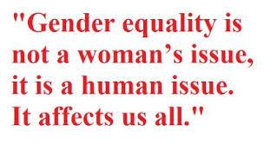
Gender equality and the empowerment of women and girls are critical to building stable, democratic societies realizing human rights furthering international peace and security growing vibrant market economies addressing pressing health and education challenges and ensuring effective and sustainable development. According to the World Economic Forum’s Global Gender Gap Report 2015, Pakistan ranks 144 out of 145 countries worldwide. Large gaps continue to exist between men and women in health, education, politics, and economic participation. Factors contributing to high inequalities for women include gender-based violence, restricted mobility, and lack of Education little awareness of rights, lack of access to and ownership of resources and assets, and limited access to social services.
To provide central place for all gender related activities and to implement MUET gender equity policy and to transform policy principles into action plans Women Resource Centre was established under the auspices of women society of engineers in MUET .It aims to serving as a central facility to promote gender equity, diversity and full participation of women and girls in all the activities at university. SWE takes affirmative efforts to promote women friendly culture across the university and also promotes research on gender related issues in higher education institutes and other relevant academic disciplines e.g. assist girls students in getting scholarships, trainings, internships and other learning opportunities and also organize different events for encouraging gender equity.

1.6 REGION
EDUCATIONAL SITUATION OF SINDH

Since 2010, the Sindh province has experienced many hardships due to impact of the floods. Internal displacement, destroyed crops, slow economic growth and weakened institutional infrastructure were all by products of recent events. Yet in spite of the challenges, Sindh remains committed to maintaining educational support for its population. Out of school youth are comprised of children who have never attended school and those who have dropped out of school. Sharp divide between urban Karachi and its rural counterparts, at almost 8 times more likely for girls living in a rural area to be out of school compared to the city. From the 2012 survey, an overwhelming 90% of rural girls are enrolling in government school with private, madrassas and other forms of education comprising the remaining 10%. Of those attending students attending madrassas, girls are the greatest share of the enrollment. In addition girls’ enrollment in a specific type of school was found to be statistically significant, suggesting that there is a relationship to be explored further, regarding which schools parents decide to send their girls. As we see throughout our concerned region, there is inequality in gender Ratio is 70:30.

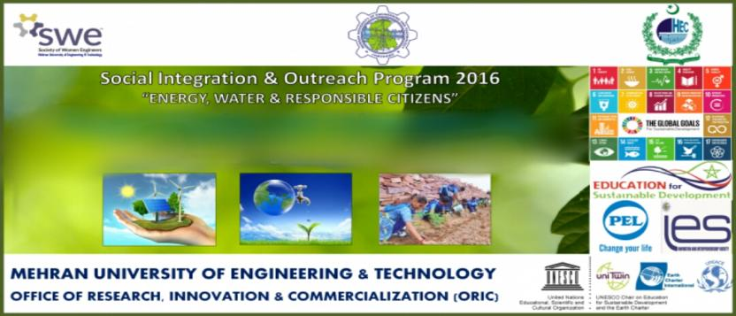

2 PROJECT

The project was led by DR Zulifqar Ali Umarani. The main focus of project was training, awareness and implementation considering “energy, water and responsible citizen” part of the goals 4,6,7 SDGS. Project meant to facilitate the schools with clean water by providing them water filters and chillers and clean energy by installing solar panels which allow students to read and write when electricity breaks down. Around 30 collages /school were visited in Jamshoro, Kotri and Hyderabad but due to limited budget, time duration and team of the University reached out to 5-6 neighboring schools and targeted students in 11th and 12th grades. 200-250 students were enrolled from each school, meaning a total strength was more than 1000 girl students.
The University had the expertise, human resources and the capacity to make this initiative successful. The University selected a dedicated team which developed the training/workshops curriculum and conduct preparatory meetings with management of schools. Then the University conducted ToT (Training of trainers) of nominated school faculty with partnering university faculty. These trainers carried out training of students and encourage them to develop SDGs based projects of which selected projects was financed and implemented. This program encouraged the schools to integrated ESD in their regular curricula. And In addition, the project envisages providing support for one pilot project in each school.
The main objectives of project was to train ESD aware faculty and students in schools, to show by practical example the benefits of Energy Efficiency and Water Conservation and to create SDG awareness in general and bring knowledge for the benefit of other students.

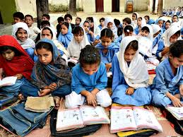
2.1 OBJECTIVES OF SIOP

- Preparation of Education for Sustainable Development: Food, Water and Society Training Curriculum
- ToT Train 10-12 ESD Trainers from Schools and 10-12 Trainers from the University. Total 20-24 Trainers.
- Conduct Baseline study at schools to determine SDG awareness.
- Train 200-300 Students in ESD: Energy, Water and Society.
- Implement small 1 ESD pilot project in each school: total 5-6 pilot projects (ex. Solar PV system)
- Implement student team developed projects. At least 2 from each participating school: Total Student projects implemented 10-12.
- Create SDG awareness in 5-6 schools via interactions with Management, Faculty and Students
- Educate the generation for betterment of coming generation and vice versa
- Empower girls to attend school, seminars, and events and encourage them to participate and organize the event.

2.2 STRATEGY AND PROGRAM FOCUS

Under its social integration outreach program MUET & HEC makes investments to achieve two overarching outcomes:

- Reduce gender disparities in access to, control over, and benefits from resources, wealth, opportunities, and services, economic, social, political, and cultural
- Increase capability of women and girls to realize their rights, determine their life outcomes, and influence decision-making in households, communities, and societies
- These outcomes are especially important for females who are marginalized or excluded due to ethnicity, gender identity, sexual orientation, lack of income, disability, or other factor
- To make them awareness of the SDGs and importance of the clean water and affordable energy.

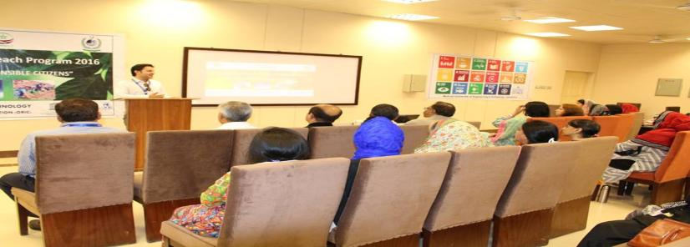

“Dr. Zulfiqar giving program overview”
2.3 LIMITATIONS

Most of the government schools and colleges in the region were found to have dreadful need to bring change, It has been a great challenge for us to select limited number of the girls’ schools and colleges that have dire need of change and then encourage them to come forward to participate in activities of this program. After selecting schools it became hard for us to regularly visit each school/college which was on far distance from each other in the region. The given time duration for completion of the Social Integration Outreach Program was only four months, it was difficult for us to manage time to make it possible to visit and identify schools, plan the schedule, train the trainers and implement the project plan, with limited number of supporting staff which influenced the working capability. The limited budget of 10 million only also made this difficult to introduce more facilities to schools because it was not possible to avail water chillers and filters, solar panels, lights and fans to all schools with narrow funds but all possible efforts were made to accomplish this project keeping all the challenges in mind.

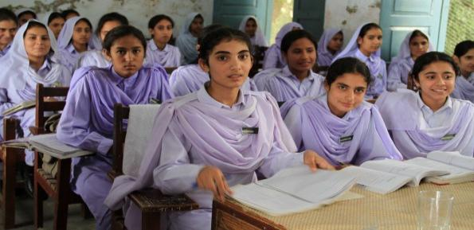
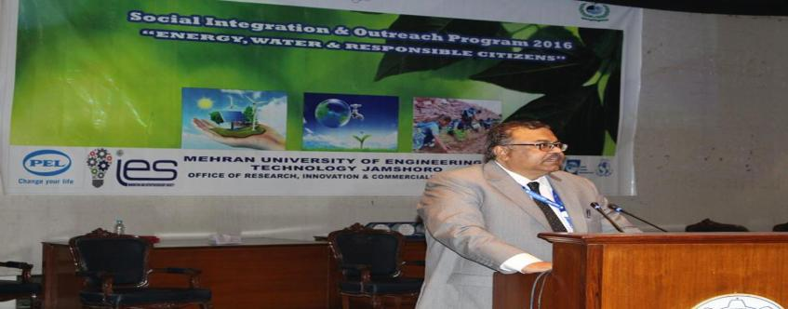

“The Vice Chancellor talking at Main Auditorium MUET”
3 PROJECT ACTIVITIES

3.1 IDENTIFYING SCHOOLS

The aim of the project was to bring forward those government schools and colleges which are facing a lot of problems regarding basic needs of health such as clean water and energy where students with lower income background are enrolled. The main focus to facilitate women and make awareness among them to come forward and get proper education to be strong, independent and that they have equal rights in society as compared to men. For putting forward this idea about 30 schools were visited in Hyderabad, jamshoro and kotri and then the University selected out 5 neighboring schools - Zubaida Govt Degree Girls College, Hyderabad - Govt Degree Girls College, Kotri - Govt Girls Higher Secondary School, Jamshoro - Mehran Public Higher Secondary School, Jamshoro - Govt Girls College, Qasimabad because these schools were found extremely low income institutes with essential problems and management of these schools highly appreciated the concept of this program and equally participated for empowering women and creating consciousness about importance clean water, clean energy and their responsibilities towards society.

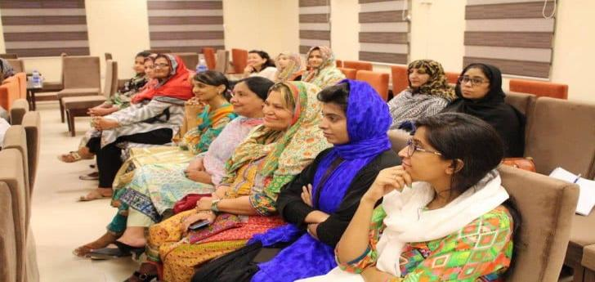

“VC addressing visiting faculty members from various schools/colleges”
3.2 TRAINING OF TRAINNERS (TOT)

“Give a man a fish and you feed him for a day. Teach a man to catch fish and you feed him for a lifetime.” Training the trainer is like teaching a man to fish. Train one trainer and they have the ability to impart their knowledge on many within their own organization. There is certainly a benefit to leveraging investment in training in this way. To equip teachers to impart education for sustainable development, the training of trainers within the ‘Social Integration & Outreach Program’ had been developed by Mehran University of Engineering & Technology, in collaboration with the Higher Education Commission. This training focused on ‘Energy, Water and Responsible Citizens’, part of the goals 4, 6 and 7 of the SDG The 3-day training became part of the bigger SIOP project under which Mehran University developed projects with the students and provided pilots systems like Solar PV to Schools/Colleges with the hope that through this program, students shall learn to utilize energy & water in a sustainable manner and play their role as powerful agents of change. And Mehran University shall continue to play its role as the elder brother and support development in the region. The University composed a dedicated team which developed the training/workshops curriculum and conducted preparatory meetings with management of schools in which about 30 teachers were trained for 3 days. The University conducted ToT of nominated school faculty with partnering university faculty. The main topics discussed in trainings of trainers were Clean Water, Clean Energy and Active Citizen Program by Ms.Shabnam Baloch, Zulfiqar Ali Umrani and Abdul Bari Noonari respectively. Subsequently, these trainers carried out training of students and encouraged those to develop SDGs based projects of which selected projects were financed and implemented to encourage the schools to integrated ESD in their regular curricula.
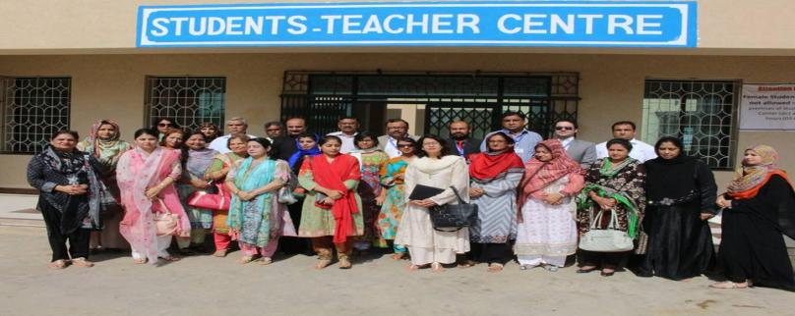

“Group photo of all MUET team and trainers from selected schools/colleges”

TRAINING MODULES

DAY 1
THEME OF THE DAY: SUSTAINABLE DEVELOPMENT
GOAL 7 CLEAN AND AFFORDABLE ENERGY
FORTABLE ENERGY
BY: DR ZULIFIQAR UMRANI
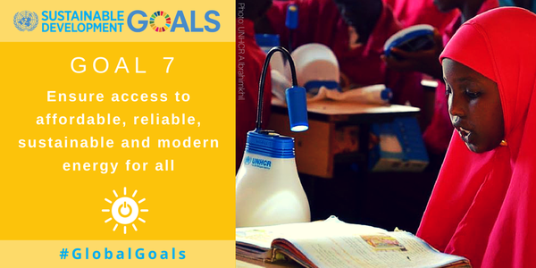

SUSTAINABLE ENERGY OVERVIEW
ENERGY EFFICIENCY AND CONSERVATION

Developing and emerging economies face a two-fold energy challenge in the 21st century Pakistan being third world country and under developing country has a huge amount of shortage of energy. There are many reasons for this shortage. Top of them is the Pakistan ranks seventh among the most adversely affected countries by climate change on Global Climate Risk Index (2017).
Wasted by some corrupt people and politicians? Energy is essential part of country's progress. Now a days everything relays on energy. During World War 2 (1939-1945) Germany had enough energy to fight the war and to provide energy to its people. Countries have energy reserved for 80 years.

Energy efficiency & Conservation have some basic activities.
To stop the wastage of energy per day.
To Decrease the consumption on daily basis
To use good electronic devices which do not consume much energy
And to repeat this process on daily basis
CLIMATE CHANGE

Climate change is basically caused by the change in weather, melting of glaciers and change in temperature. Climate change is very dangerous for the countries like pakitan, india, bangladash Afghanistan climate change floods and rainfall.

ENERGY AUDIT
Energy audit can easily done in school/college home or office. All you have to do is to regular note the usage. Note the consumption of energy daily. Note the total devices being used in a specific day. We can easily audit energy
“Students attending seminar on climate change”
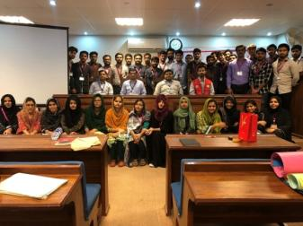

COST BENEFIT ANALYSIS

There are six broad categories of renewable energy technologies—biomass, wind, solar, hydro, geothermal and marine. They can be tapped using a variety of conversion technologies or processes to produce a range of energy services, including electricity, heat (or cooling), fuels, mechanical power and illumination.
In dispersed, off-grid applications, by contrast, intermittently may pose less of a problem and renewable technologies may be more cost-effective than the next available conventional option. In addition, their modularity that is, the

Fact that many renewable energy technologies can be deployed in relatively small unit increments may be advantageous from a cost and risk standpoint in many developing countries.
Energy efficiency & Conservation have some basic activities.
- To stop the wastage of energy per day.
- To Decrease the consumption on daily basis.
- To use good electronic devices which do not consume much energy. And to repeat this process on daily basis

DAY 2
THEME OF THE DAY: SUSTAINABLE DEVELOPMENT
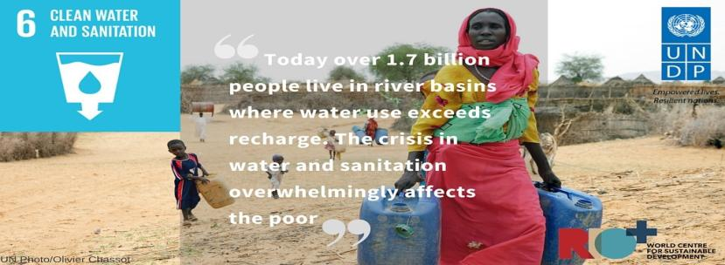
GOAL 6-CLEAN WATER AND SANITATION

PAKISTAN’S VISION OF WATER RESOURCE MANAGEMENT

According to the presentation of Minister for Water and Power at Pakistan Development Forum May 14, 2003, the irrigation system of Pakistan is the largest integrated irrigation
Network in the world, serving 36 million acres of contiguous cultivated land. The system is fed by the waters of the Indus River and its tributaries.
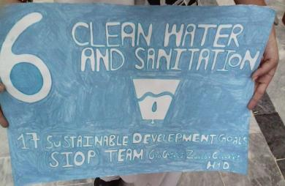
Two major issues in the water sector are found institutional & management issues and technical issues. Institutional and management issues such as need for national water council to oversee integrated water sector planning, development and management, inadequate stakeholder participation, lack of public awareness & deficient water information, lack of financial sustainability in water sector services , low private sector investment or participation. And technical issues such as increasing demand of water for food, fiber and power, combined use of surface and ground water, inefficient use and inequitable distribution of water, especially in irrigation, deteriorating water quality, inadequate drinking water supply and poor quality of service, deteriorating infrastructure in the irrigation and drainage sub-sectors, environmental degradation of irrigated lands, safe disposal of saline drainage effluent to the sea. By 2025, Pakistan should have adequate water available through conservation, development and good governance. Water supplies should be of good quality, equitably distributed and meet the needs of all users through an efficient and integrated management, institutional and legal system that would ensure sustainable utilization of the water resources and support economic and social development with due consideration to the environment, quality of life, economic value of resources, ability to pay and participation of all stakeholders.
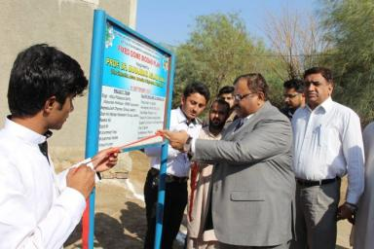
“Inauguration of Biogas plant”
“Students promoting SDG 6”

DAY 3
THEAM OF THE DAY SUSTAINABILITY GOAL DEVELOPMENT
4-QUALITY EDUCATION & RESPONSIBLE CITIZEN
BY ABDUL BARI NOORANI

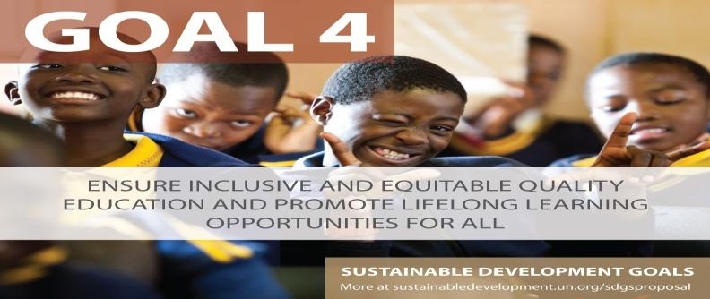

RESPONSIBLE CITIZEN

It is usually stated that young people are the future. What can be easily overlooked is that they are also the present. Their actions now also contribute to the issue of whether sustainable development is being achieved. When a young person feels emotionally secure and self-confident, learns to take full responsibility for his/her actions, respects self and others, and trusts his/her own thinking and respects the opinions of others even when different from theirs, she or he is likely to behave in socially responsible ways. These socially responsible behaviors are essential to sustainable development.
Under this project the purpose of training session on Responsible Citizens was:
- To understand The Responsible Citizen approach to learning.
- Identification of local issues.
An activity was conducted under this training which allowed participants to think about the certain issue in their surroundings, its impacts and solution. Other activities were conducted through Boston Matrix, 4 words, Conflict circle etc to support participants to identify how realistic their ideas for social action are, to negotiate the importance of participation and process, to develop understanding of intercultural dialogues and to illustrate that there is more than 1 side to a conflict. Over all the activities were for making them understand that Active citizens are people who care about their local communities and the places they live. They want to make a positive difference or make something happen by having their say. Active citizens, by taking part, can help decide and influence a range of things, including how things are run and what gets funded and built.

3.3 MONITORING KNOWLEDGE TRANSFER

Master trainers provided trainings to aware trainers and students about SDG’s at selected schools and Colleges. We continued our day to day visits for monitoring the task and the evaluate training conveyed from the teachers to students related to focus SDGs and that actual work is going on or not and what is the progress of the program and to look after their activities which have been practically implemented. And Beside that our team was implementing the priority focuses was encouraging students to
3.4 PRACTICAL IMPLEMENTATION
Become more capable. The role of team needed to be further enhanced to the design of incentives for academics when working and to the absorptive capacity of academic knowledge within schools. The purpose of monitoring knowledge transfer was to managing innovation and evaluating expected outputs. Training suggests that trainers are the strongest source of initiating knowledge transfer often with limited time and facilities. It is important to focus on nurturing and accelerating the development of school.

5th International Conference on Energy, Environment and Sustainable Development (EESD2018)

Our team recognized the needs of the selected government schools and colleges focusing SDG 5 and 6 clean water and clean energy and came across with different health issues faced by students. Students used to read and write with a very little or no electricity in their library and classrooms in their schools. The passion of reading, writing and working hard don’t work more powerfully unless the basic facilities are provided to students whom without it becomes hardest job such as electricity because students were found doing nothing productive when there was no light in their dark classrooms and libraries. As clean water plays an important role to maintain human’s health unless they don’t get clean water a basic need on the place they spent most of the time, they remain unhealthy and get to suffer from different harmful diseases which don’t even let them go to school and attend their classes regularly. Taking step towards solution we successfully implemented the project to facilitate students with solar panels for renewable energy, Batteries, 4 fans and 6 LED lights in classrooms. Having limited budget it was not feasible to further install water filters and chillers, we had public and private partnership with PEL to provide water filters and chillers in all selected schools for providing cool and clean water students.

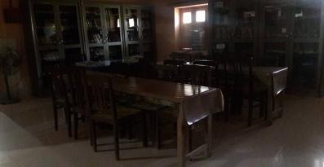
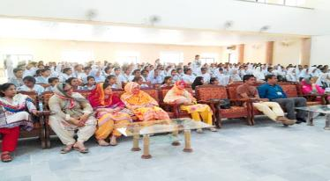
"At celebration Day"

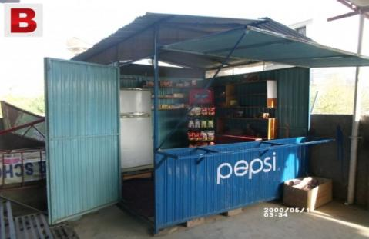
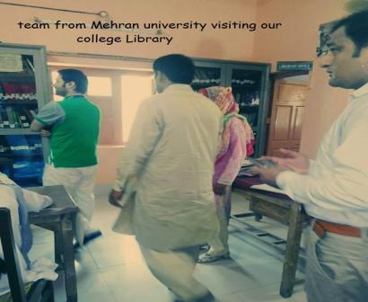
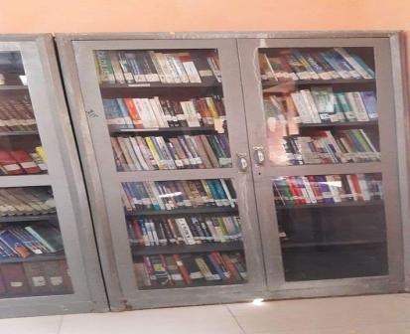

“Condition of school library”
“Program Manager visiting college faculty”

3.5 STUDENTS PROJECTS AND ACTIVITIES

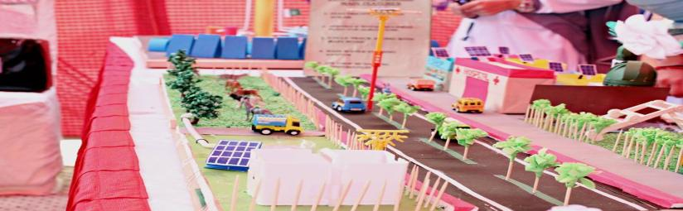

The great thing about this was to get different small projects done by students themselves following the guidance that brought greater changes in their schools and colleges. Students promoted sustainable development goals through amazing activities and performances in their schools/colleges. They enjoyed contributing their efforts for their learning spaces which brought positive changes in their institutes. Trainers initiated Green club and other teams to maintain clean and healthy environment in college by conducting different SAP’s, celebrating cleanness day, providing clean water by improving the condition of water tanks, celebrated hand washing day by teaching them right methods of washing hands, creek plantation, bottle gardens by recycling bottles, recycling shoppers and other waste materials, renovating canteens to promote healthy food and developing wall of kindness to pay their social responsibility toward society.

GREEN CLUBS
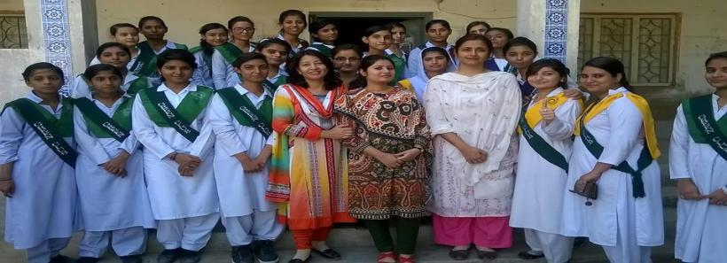

“Members of green club in govt girl’s degree college kotri”

Schools/colleges initiated Green clubs and other such type of teams to maintain clean and healthy environment where every student participated to support the idea to bring change in environment of school considering it as moral responsibility of everyone to promote the initiative of joining hands to save planet. The Green club team was established where some teachers and students became members of the club and they intend to keep maintaining the green club activities for future wellbeing.

Protect Our Species"... Earth Day'19 Celebration
“Students and teachers celebrating cleanness day at Zubaida girl’s college Hyderabad”

With the slogan of "Protect Our Species" Earth Day 2019, organized by Institute of Environmental Engineering and Management in collaboration with WWF Pakistan (ILES Freshwater Programme) & USPCAS-W MUET. Student from IEEM, USPCAS-W, Electrical Engineering department and Electronics Engineering Department participated in Debate, Poster and Video Documentary Competition.

The celebration started with awareness walk. Prof. Dr. Khan Mohammad Brohi Dean Faculty of Architecture & Civil Engineering joined the event as chief guest. Ms. Hamera Aisha, Manager Conservation Wildlife, Ms. Komal Naeem and Mr. Love Kumar Senior Officer Freshwater programme were the representatives from WWF Pakistan.

Soon after the presentation from WWF Pakistan, the three judges, one from IEEM, one from USPCASW and one from WWF Pakistan were requested to evaluate the poster designed by various participants . As soon as judges finished the poster evaluation, other three judges were ELDC, Architecture and WWF Pakistan were requested to evaluate the speech competition. As soon as speech competition finished, other three judges were requested to judge the documentary competition.
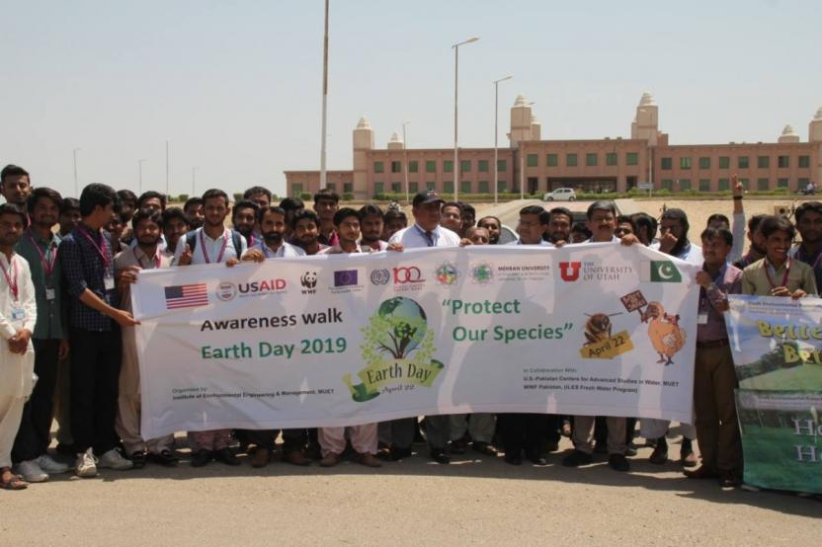

Protect Our Species"... Earth Day'19 Celebration

Memorandum of Understanding (MoU)
Institute of Environmental Engineering and Management, Mehran UET, Jamshoro and Hangzhou Jinjiang Group Sanitation Services Co. Pakistan (Pvt) Ltd. have signed a memorandum of understanding (MoU) to collaborate on research and technical consultancy. The MoU was signed by Prof. Dr. Mohammad Aslam Uqaili, Vice-chancellor, Mehran UET, Jamshoro and Peng Zhezhuang, Chief Executive Officer (CEO), Hangzhou Jinjiang Group at V.C secretariat, Mehran UET, Jamshoro. Whereas, the Hangzhou Jinjiang Group, is duly licensed and acquired contract in Pakistan for waste management.
Through this MoU, IEEM and Jinjiang Group Sanitation Services Co. Pakistan (Pvt.) Ltd. will establish terms and understanding in respect of matters relating to research and development in the field of Solid Waste Management and other Environmental Services/Studies. During the ceremony Prof. Dr. Tauha H. Ali, PVC Mehran UET, Prof. Dr. Khan Muhammad Brohi, Dean Faculty of Civil and Architecture, Engr. Dilnawaz Shah, GM, Dr. Sheeraz A. Memeon, Director IEEM and Engr. Azizullah Channa, Assistant Professor and others were present. After this MoU signing ceremony, company representatives have an interactive session with faculty members, researchers and students at Institute of Environment Engineering & Management, Mehran UET, Jamshoro.
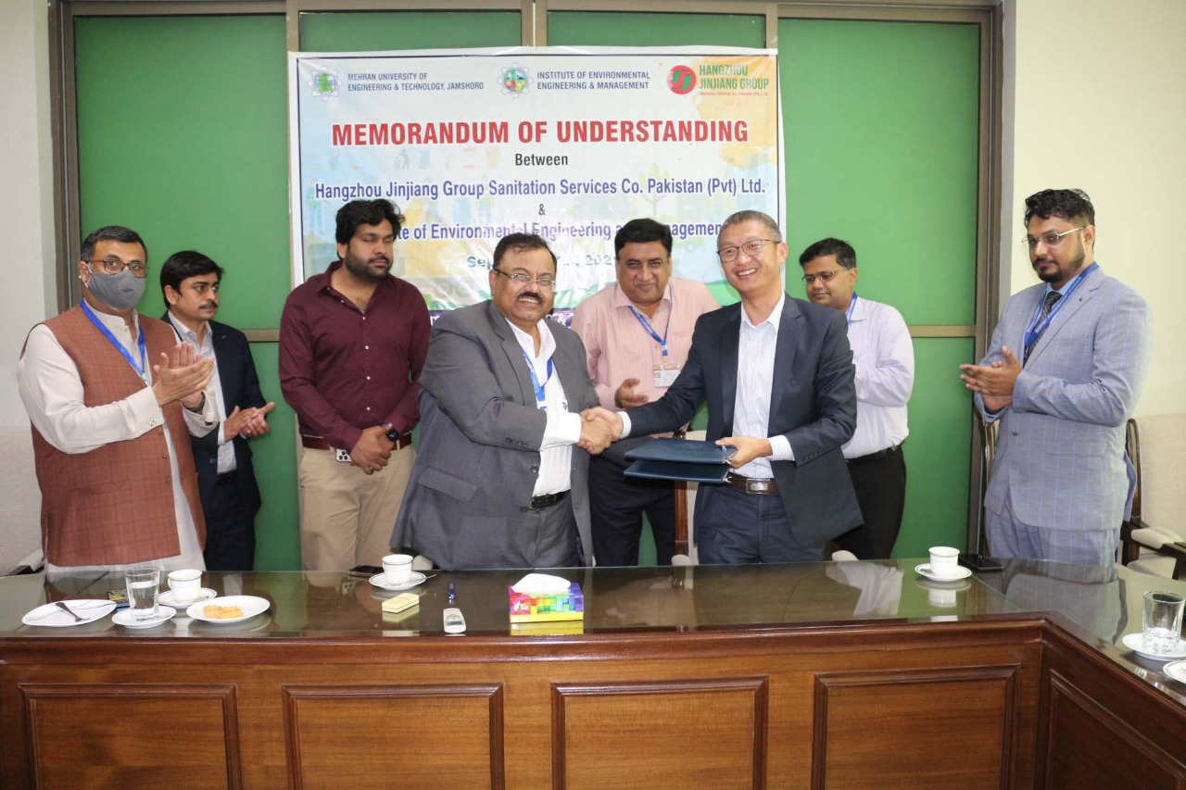
MoU between Institute of Environmental Engineering and Management, Mehran UET, Jamshoro
and Hangzhou Jinjiang Group Sanitation Services Co. Pakistan (Pvt) Ltd.

Biogas Plant Based Upon Animal Manure
The Higher Education Commission (HEC) Pakistan funded a research project under National Research Program for Universities (NRPU) titled as “Design, fabrication and optimization of fixed dome biogas plant and digest separator for underprivileged communities living at lower Indus region of Pakistan”. The Principal Investigator of this project is Dr. Sheeraz Ahmed Memon, Institute of Environmental Engineering & Management, Mehran University of Engineering and Technology, Jamshoro Sindh Pakistan and Co-PI of project is Engr. Azizullah Channa.
As biogas is a clean source of renewable energy as it is produced through anaerobic digestion and can be used for cooking, lighting, and running machinery. It also produces digested slurry which is rich in nutrients and provide nutrients to the soil in terms of soil structure improvement, water holding capacity, enhancing crop yield, and improving soil fertility. By substituting synthetic fertilizer and changing traditional manure management systems, biogas installation reduces the emission of greenhouse gases into the atmosphere as well as in less diffuse pollution from surface run off and leaching. These direct benefits will help governments meet targets for reducing GHGs and other major social, environmental, and economic benefits associated with using biogas technology. Under the right conditions a biogas plant yields several benefits to end-users in terms of less firewood collection, better cooking performance, less smoke and harmful particle emission of biogas stove compared to wood or dung fuels; production of green energy, better health more work capacity, fertilizer, better crop yields, and better health.
In this regard, four 6 m³ fixed dome biogas plants were constructed on household level to fulfill the cooking, heating, and lighting demand of households. These biogas plants were installed in Hyderabad and Matiari district and selection of areas were based on unavailability of natural gas supply and frequent availability of animal manure. The biogas plants were constructed by construction of inlet tank, digester main chamber, outlet pit, inlet pipe, dome, and composite pit. It was noticed that an average biogas production was achieved to 1.9 m³/d at optimum mesophilic condition. Following photographs shows the fixed dome biogas plant construction and installed in Hyderabad district. Following figures show construction of biogas plant.

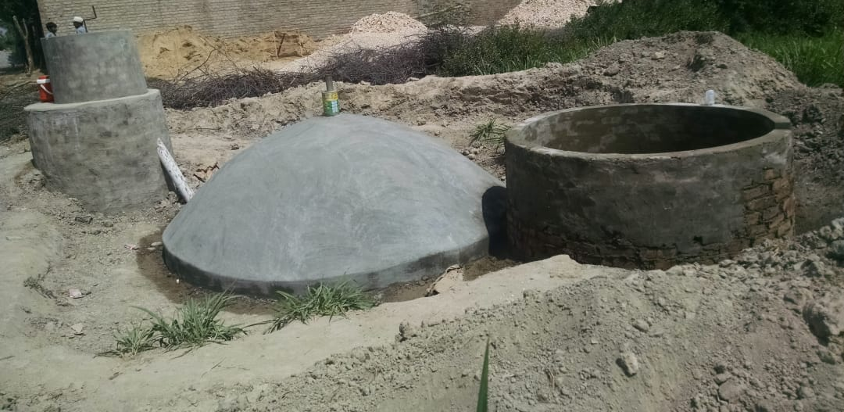
Biogas Plant
One day awareness webinar on Integrated Solid Waste Management in Pakistan
One day awareness webinar on “Integrated Solid Waste Management in Pakistan” was conducted on 12th September 2020. The invited speaker was Dr. Asim Ali Abro, Assistant Professor/Chairman, Department of Civil Engineering Technology, The Benazir Bhutto Shaheed University of Technology & Skill Development, Khairpur (Mir’s), Sindh. In this seminar, students of 1st, 2nd, 3rd and Final year of BE including ME, PhD students and faculty members of Institute of Environmental Engineering & Management participated. Dr. Abro said that the solid waste management is not the perplexing problem for developing countries but developed countries are still trying to figure out the sustainable method to deal with this menace. Currently Pakistan produces around 48.5 million tones with less than 50% of collection each day and this would be increased by increasing population & urbanization. Many of countries around the globe have a much-engineered mechanism of solid waste utilization and adopted well Integrated Solid Waste Management (ISWM) approach and getting the good out of it. Pakistan can harness the alternative sources by abolishing the conventional approach of open dumping and Landfilling. This could be possible when solid waste is managed by well-equipped system of management and the system should include fundamentals of ISWM model i.e. policies, selection of technologies, and social awareness programs. Dr. Korai concluded that the ISWM is one of the best approaches to extract energy from solid waste in the country.
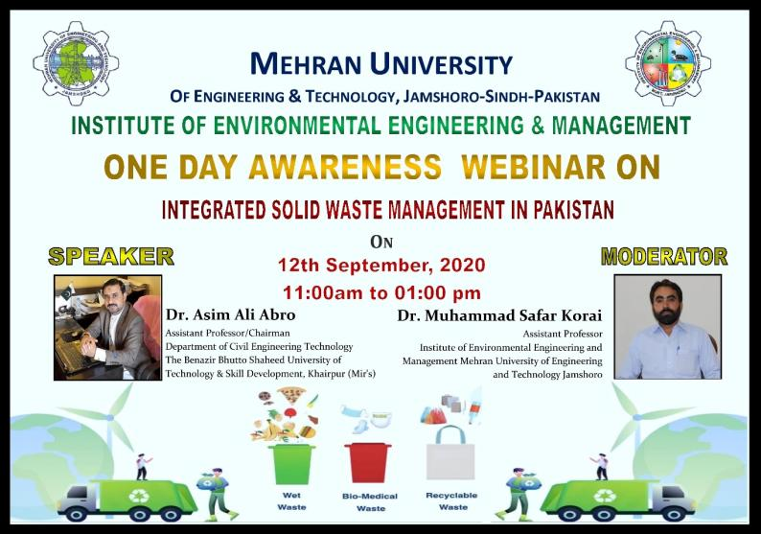
One Day Awareness Webinar
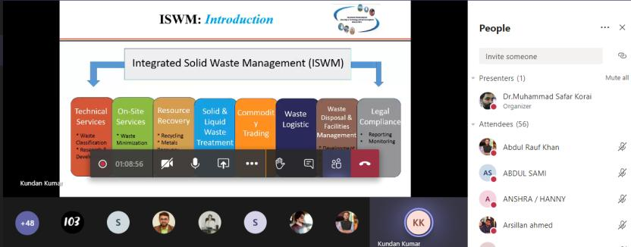
One Day Awareness Webinar

RENOVATE CANTEENS & PROMOTE HEALTHY FOOD

CELEBRTAED HANDWASH DAY

Celebrating hand washing Day is an opportunity to design, test, and replicate creative ways to encourage people to wash their hands with soap at critical times. Students were taught World Health Organization (WHO) approved techniques of washing hands and that it's a message worth repeating hand washing is by far the best way to keep kids from getting sick and prevent the spread of germs. They were taught its importance and what role does it play toward remaining healthy. This increased awareness and understanding about the importance of hand washing with soap as an effective and affordable way to prevent diseases, infections and save lives.
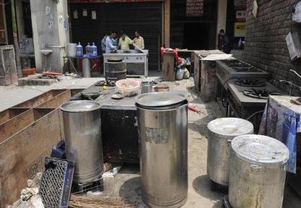
It is important that the food we eat is clean and safe. So it is essential to prepare meals in a safe, hygienic way. If germs (such as harmful micro-organisms and parasites) get into foods, they may cause food poisoning (resulting, for example, in diarrhea or vomiting). Schools renovated condition of their canteens which was worst and the food were unhygienic and there was no proper cleaning and washing of crockery. They started canteen where they cater hygienic food with good quality and clean environment to maintain health among students and teachers in schools
“Condition of school canteen”

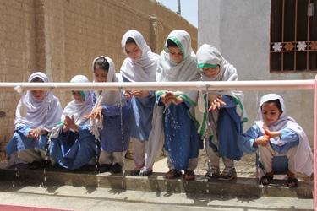

.
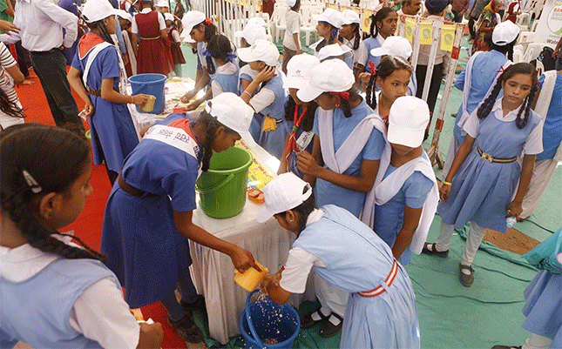
“Students learning right methods of washing hands”
"Renovated Canteen in school"

"Activities performed on cleanness day"
TESTING WATER SAMPLES
BOTTLE GARDENS

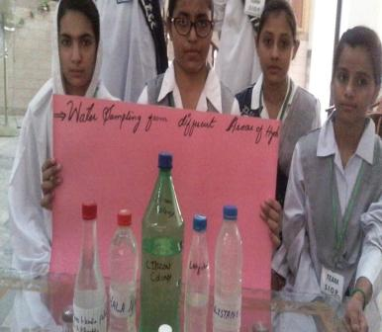
Students carried out a project on collecting Drinking Water Samples from Different Areas of Hyderabad for testing water with different chemical examinations. They tested water through different examinations and came to know that water being drank in region is not clean at all it contains a lot of germs that may cause Diarrhea, Dehydration and even death. As the global water crisis continues solutions for delivering safe, and clean water to the world’s growing population has become an increasingly pressing issue. Not only does water need to be available for consumption, but resources must also be in place to supplement water for crops, and other sanitation needs, especially in places of drought, where water is unavailable to the majority of the population. Solution do exist however, to increase access to clean water with everything from traditional wells, solar devices that decontaminate water and filtration systems.
“Water samples collected from different areas of Hyderabad”
Plastic bottle vertical garden is made of by stringing the bottles horizontally in a grid along an interior wall, which then filled up by substrate and herbs. When the ability to garden is limited by different factors, like available space or drought in the dry lands, then consider bottle gardening. The simple concept of growing plants in pots or even in plastic bottles or plastic shopping bags, offers a variety of ways to enjoy gardening and produce plants in the most difficult circumstances by the help of just some containers, the right growing medium, the right choice of plants (seeds, seedlings or young plants) and an open area, preferably with a sunny and a shady part. In these mini-gardens one can easily control the type and condition of the soil and pest control is easier since one can isolate the infected plants. Students prepared beautiful bottle gardens in their schools/colleges.

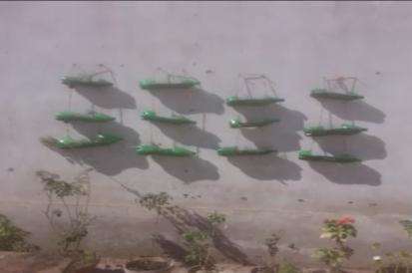
"Bottle Garden created by students"

CLEAN WATER AND SANITATION
SOLAR OVEN

The conditions of water tanks were found worst at Govt Girls Zubeda College. Students constructed and developed pipelines between water tanks and parking area where garbage and water used to stay. The pipelines were ended in the parking area where plant beds were excavated for provision of water to plants rather than wasting water.
"Proper Water pipes fitted for waste water utilization for plantation"
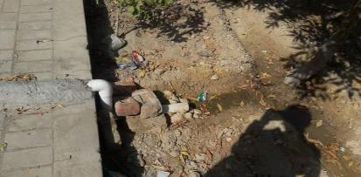
A solar oven is a device which uses the energy of direct sunlight to heat, cook or pasteurize drink. Solar ovens are inexpensive which can easily be afforded by families who cannot afford buying expensive electric ovens because it requires no fuel and cost nothing to operate and no air pollution. Students prepared a solar oven project that uses only household items such as Cardboard pizza box, Box knife or scissors, Aluminum foil, Clear tape, Plastic wrap, Black construction paper, Newspapers, Ruler, or wooden spoon, Thermometer etc and plus they learnt about absorption, insulation, and the sun's energy.

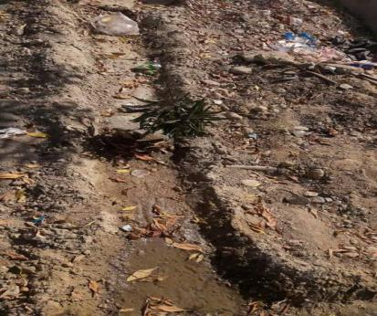

WALL OF KINDNESS

The wall of kindness (Persian: دیوار مهربانی‎‎ dīvār-e mehrabānī is a charity work phenomenon and a kind of welfare, usually done by attaching cloth hangers from outside of houses; those encourage people to donate miscellaneous useful things such as winter clothing. A wall of kindness was seen in Pakistan's Karachi on 15 January 2016, It was set up in Peshawar by Serve Mankind and afterwards it started Spreading all over Pakistan suchasRawalpindi, Lahore, Sialkot, Quetta, Khuzdar, Karachi and Hyderabad have witnessed similar walls where people are leaving clothes and other essential items for the poor. Encouraging making small contributions for those in need, the homeless may find necessary things. People also donate blankets, utensils, and things that are in good condition. Schools decorated wall of kindness with pictures and quotations of famous personalities, hangers and racks where students who cannot afford clothes, shoes, bags, books or other necessities may find it on this wall.

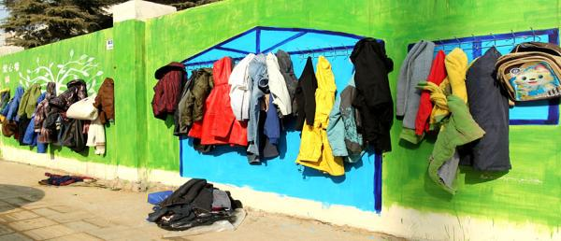
“Wall of Kindness in Govt Girls Degree College Kotri”

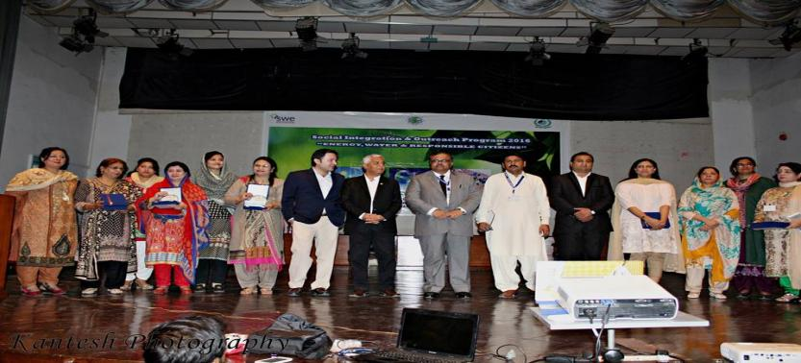

3.6 CELEBRATING SUCCESS

Social Integration & Outreach Program (SIOP) Award Ceremony was celebrated at Mehran University of Engineering & Technology (MUET), Jamshoro. The panel led by Vice-Chancellor his presiding address, the Vice-Chancellor, Prof. Dr. Muhammad Aslam Uqaili spoke of the necessity of empowering girls pursuing STEM. He emphasized the need to take ownership of our society and protect the environment. Dr Tariq Banuri, from the University of Utah, USA discussed about the Sustainable Development Goals and how society can achieve them. Pro Vice-Chancellor Prof Dr Taha Ali gave the welcome speech to auditorium packed with girl student’s .Dr Zulfiqar Ali Umrani, project director of the program gave the overview of the project and talked about inciting behavioral change for tangible change. And the presentation from each collage about success of the event .Hon. Jean-Francois Cautain, European Union Ambasador to Pakistan, Mr Neil Buhne, Resident Coordinator UN - Pakistan and Representative Head of UNDP, Ms Vibeke Jensen Head of UNESCO Pakistan and Ms Arvea Marieni of GCM Consulting addressed the audience via video. The participating Colleges/ High-Schools were: - Zubaida Govt Degree Girls College, Hyderabad Govt Degree Girls College, Kotri - Govt Girls Higher Secondary School, Jamshoro - Mehran Public Higher Secondary School, Jamshoro - Govt Girls College, Qasimabad. During this program the university imparted ESD trainings to faculty members and aided the training of more than 1000 female students. The students developed exciting projects in relation to Energy, Water and Responsible Citizens. And the university has successfully installed pilot Solar and Clean water systems at the colleges. The water systems were contributed by PEL Pakistan. University celebrated the success of the program, which has proved to be low-cost, high-impact and high-outreach. University held this project celebration program to showcase the student projects where students displayed their projects and performed amazing dramas and other activities. University also celebrated award ceremony in which 50,000 Rs had been distributed to reward for successful projects among students and in last provided refreshment to all the audience who became Part of this grand celebration of social integration & outreach program

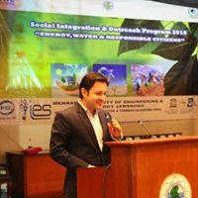
"Program Manager addressing vote of thanks"
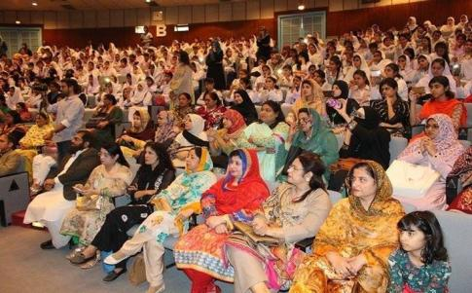
"Participating Colleges/Schools at MUET for celebration"

3.7 WAY FORWORD

"Making products from recycling materials"
3.7 WAY FORWARD 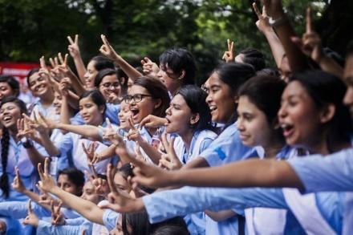
Pakistan with highly talented people, only needs conducive, enabling & encouraging environment which may help them to exploit their talent mental faculties & utilize their energies & potential for socio economic benefits & empowerment. This is what MUET believe to better exploit & utilize their capabilities for advancement of science & technology & knowledge power to socio-economic benefits to all segments of the society as well as the nation. To encourage women to study is very necessary as women have the equal rights to take a good education for their better future. They have the rights for empowerment to make a decision of his life. They need not to depend on the other. Girls have rights to everything, and Women empowerment should grow all over the Pakistan for economic development.
Mehran University of Engineering and Technology Jamshoro will be looking forward to provide more facilities to needy institute to encourage quality education and gender equity in collaboration with HEC in future. It can bring prosperity and great change in society if the projects are provided an adequate amount of funds, supportive staff and sufficient period of time.

