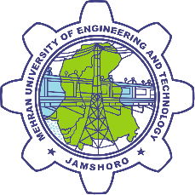
Mehran University of Engineering and Technology, Jamshoro, Sindh, Pakistan

Application Form for Short Course on Chinese Language Program 2017

A) PERSONAL INFORMATION:

Name of Applicant:
[Please fill in BLOCK letters]

S/o, D/o, W/o:

Date of Birth:
Place of Birth:

Address:

Please Affix
Photograph here

Tel No (Residential):

Cell No:

Email Address:

C.N.I.C #:

B) EDUCATION BACKGROUND:

Academic Record | Name & Place of Institute | Passing  Year | Marks  Obtained | % / Div.
Matric / O level / Equivalent
Inter Science / A level / Equivalent
Graduation
Degree Name:
Master
Degree Name:
Other (PhD)Degree Name:

C) EXPERIENCE:

Sr. No. | Company / Institute Name | Position / Designation | Duration | Total  Experience
1.
2.
3.
4.

D) DUHS RULES AND REGULATIONS:
- Mandatory requirement to appear in final examination.
- Eighty percent (80%) Attendance
- Submission of all assignments

UNDERTAKING

This is to certify that all the mentioned information are correct and I will abide all the Rules and Regulations, failing to which management has reserved the right to cancel my admission at any time.

Applicant’s Signature
Dated:

E) DOCUMENTATION REQUIRED:

1. Two attested copies of following documents:

a) C.N.I.C

b) Complete Academic Certificates c) Experience Certificates

2. Updated Curriculum Vitae.

3. Three Photographs.

4. One photocopy of duly filled application form for acknowledgement.

5. Copy of Bank Challan paid (Rs. 3000/-) in favor of Mehran University of Engineering & Technology, Jamshoro (Processing fee non-refundable).

