Joint Degree in Masters’ in
Energy & Environmental Engineering
Offered by
MEHRAN UNIVERSITY OF ENGINEERING & TECHNOLOGY, JAMSHORO PAKISTAN
&
SHENYANG AEROSPACE UNIVERSITY, CHINA

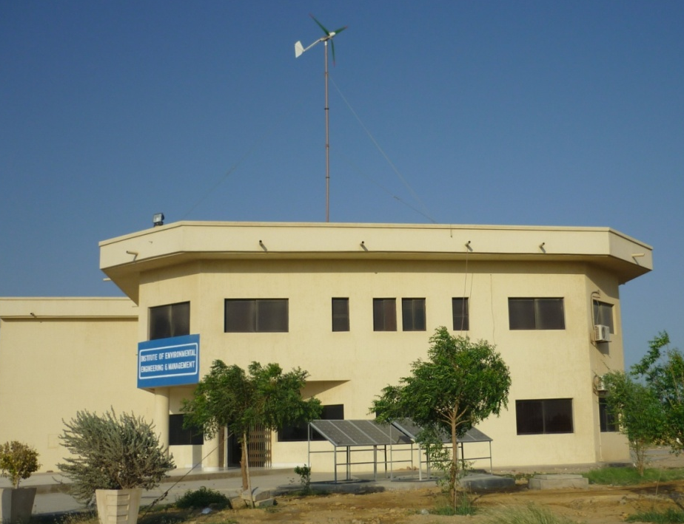
Prospectus- 2015

Introduction

The components of Environment (Atmosphere, Land, water and Ocean) are being threatened by Anthropogenic (Mankind) and Industrial activities, which required to be cared for living Organisms. Greenhouse gases, unattended solid waste, over exploitation of water resources and disposing of waste water in to ocean generates Air pollution, water pollution, land degradation and marine pollution problems respectively. The course syllabus of Energy and Environmental Engineering makes students expertise to reduce the pollutant controlling equipments, solid waste management,water treatment techniques and wastewater treatment techniques specially focusing the pollution due the conversion of primary sources of energy into the secondary and tertiary. The course also highlights Environmental Impact Assessment of energy projects, Environmental Health and Safety and monitoring/auditing tools of ISO 14000 and ISO 18000. The course work of Postgraduate Diploma is comprised of 33 credit hours with 11 subjects to be completed in three semesters in full time evening program. After qualifying 60% overall marks in all subject and 50% marks in each subject, candidate will be eligible to take Masters Thesis with minimum possible time of 6 month.

Institute of Environmental Engineering& Management is offering academic excellence to the graduate students through will- experienced and highly qualified visiting faculty available in University and outside as well as internship with Industries.

Vision

To produce Energy and Environmental Engineering Expert who share their skill in the establishment of Environmental Management system in all Industry, Agricultural land, Irrigation and Drainage infrastructures, communication network systems and Rural-Urban Utilities to enter in the development of 21st Century goal of making national Economy as per World Trade Organization (WTO) requirements.

Objectives

- To make Post Graduate/Master level students skillful by achieving the following goals to become useful for re-construction of National Environmental Economy.

- To explore the renewable and non-renewable energy sources that fulfill the National Energy requirements.

- For making Water potable, learning methodologies of Water Treatment Plant, water-softening techniques Osmosis techniques shall be procured.

- For making safe Disposal of Wastewater from various development learning methodologies of Wastewater treatment technologies; like Wastewater treatment Plant, evaporation Ponds, Oxidation Ponds and in addition the design of Pipe network systems shall be procured.

- For removing the Soil Waste Problem Cities, industries, town and rural areas, a very comprehensive learning methodologies can be extended; like understanding the Generation, collection, transferring and disposal techniques of Municipal Solid Waste, industrial Waste and Hospital Waste.
- To make efforts to clean the Atmosphere, the learning methodologies; like understanding air pollutants and the design of Air pollution Control equipments shall be procured.

- To make student capable to design the project in which he shall learn implementation of Environmental Managements system under the Umbrella of ISO-14000, Environmental Impact assessment and Strategic Environmental Assessment.

The Faculty

Director:
Prof. Dr. Khan Muhammad Brohi
Phone: 022-2772253 Ext: 7300

Professors:
Dr. Khan Muhammad Brohi
Ph.D. Japan

Dr. Rasool Bux Mahar
Ph.D. China

Associate Professors:
Dr. Abdul Razaque Sahito
Ph.D. Pakistan

Assistant Professors:
Mr. Muhammad Ali Memon
M.E. Pakistan

Dr. Sheeraz Ahmed Memon
Ph.D. Korea

Lecturers:
Mr. Imdad Ali Kandhar
M.E. Pakistan

Mr. Muhammad Safar Korai
M.E. Pakistan (On Study Leave for Ph.D.)

Mr. AzizullahChanna
M.E. Pakistan

Mr. Zulfiqar Ali Effendi
M.E. Pakistan

Shared /Visiting Faculty:
Prof. Dr. Khanji Harijan
Ph.D. Pakistan

Prof. Dr. Muhammad YarKhahwar
Ph.D. United Kingdom

Joint Degree Program
The Institute of Environmental Engineering &Management is offering joint Masters’ degree program in Energy and Environmental Engineering.

Eligibility Criteria
Candidates having the First Division in only Bachelor of Engineering (B.E) or B.Sc (Engineering) in following disciples are eligible to apply:
- Environmental Engineering
- Energy & Environment Engineering
- Chemical Engineering
- Electrical Engineering
- Mechanical Engineering
- Mining Engineering
- Metallurgy and Material Engineering
- Industrial and Manufacturing Engineering
- Petroleum and Gas Engineering
- Textile Engineering
- Civil Engineering

Study Plan
The joint Masters’ degree program in Energy and Environmental Engineering comprises of four semesters, two in each year. As per program all the students will study first year (First & Second Semester) in Mehran Universityof Engineering & Technology, Jamshoro Pakistan. For the second year, students will be given option to either to complete Second year (Third and Fourth Semester) in Mehran University or can go to Shenyang Aerospace University, China.

Courses Offered

M.E. (Energy and Environmental Engineering)
First Year Study Plan
First Semester |  | C.H. (Th./ Pr.) | Marks
1 | Energy & Environment | 3-0 | 100
2 | Air & Noise Pollution Control & Meteorology | 3-0 | 100
3 | Physico Chemical Processes in Environmental Engineering | 2-0 | 50
 | TOTAL | 8-0 | 250
Second Semester
1 | Water & Wastewater Engineering & Treatment | 3-0 | 100
2 | Modeling in Environmental Engineering | 2-0 | 50
3 | Advanced EIA& Management | 2-0 | 50
4 | Occupational Health & Safety | 2-0 | 50
 | TOTAL | 9-0 | 250
Second Year Study Plan
Third Semester |  | C.H. (Th./ Pr.) | Marks
1 | Municipal & Hazardous Waste Management | 3-0 | 100
3 | Clean Energy Technology | 3-0 | 100
3 | Waste to Energy Processes | 3-0 | 100
4 | Statistical Product & Services Solution | 0-1 | 50
 | TOTAL | 9-1 | 350
Forth Semester
1 | Thesis | 6-0 | ---
NOTE:C.H. = Credit Hour, Th. = Theory, Pr. = Practical

Course Contents

1. Energy & Environment

Renewable resources and fossil fuels, i.e, Hydraulic, geothermal, wind, tidal, solar, biomass energies, Oil, gas, coal, and oil shale energy production, Environmental consequences of the fossil fuels production and utilization, Flue gases, NOx formation and reduction; Combustion emission control, Thermodynamic fundamentals, Natural gas combustion, Coal combustion, Estimating steam power, Fundamentals of nuclear power, Nuclear power systems comparing fission and fusion energies, Nuclear power health effects, Safety requirements for nuclear power plants, radioactive waste management and disposal, Acids deposition, Atmospheric warming, Coal ash treatment; Waste management, Greenhouse gasses, Greenhouse effect, Characteristics of the present-day atmosphere, Key points of the adiabatic theory Prognostic atmospheric temperature estimates, Impact of anthropogenic factor on the Earth’s climate, Influence of the World Ocean on the atmospheric content of carbon dioxide.

2. Air & Noise Pollution Control & Meteorology

This advanced course focuses on various technical aspects related to air pollution control and their management issues. The topics include micrometeorology; air dispersion modeling; advanced air pollution control (e.g. process modification, energy audit and emission trading); case studies on control of emissions from stationary and mobile source; Transport and Dispersion of Air Pollution; Indoor and outdoor air pollution, control of stationary emissions (particulate matter and gaseous). Climate Change. Noise pollution, detrimental effects, noise properties, terminology and characterization, noise transmission, traffic noise prediction, noise control, standards.

3. Physico Chemical Processes in Environmental Engineering

Stoichiometry, Chemical Equilibria and Kinetics, Reactors and Reactor Theory. Principles and Design of Physico-Chemical Treatment Processes; Sedimentation, Coagulation and Flocculation, Filtration and Disinfection, Membrane Processes, Chemical Oxidation, Distillation, Water Softening, Ion exchange, Adsorption, Corrosion, Sludge Management. Advanced techniques of water, soil & air analysis. Application of HPLC, Spectroscopy and Gas Chromatography in Environmental samples.

4. Water & Wastewater Engineering & Treatment

Drinking water quality and human health. Water quality guidelines and standards. Fluoridation, River Osmosis, Membrane technology, chlorination. Pre-design Studies, Process Kinetics. Mass/Balance. Reactor Design, Pretreatment Clarification, Chemical Treatment, Biological Treatment (Aerobic and Anaerobic) and Disinfection, Sludge Management, Natural and Aquatic Plants-Based Treatment Systems, Effluent Disposal and / or Reuse, Plant Hydraulic, Flow Measurements, Pumps, Instrumentation and Control. Methods and designing of wastewater treatment plants.

5. Modeling in Environmental Engineering

Fundamental Principles of Deterministic and Stochastic Modeling applied to Environmental Problems. Development of models, General Mathematical Formulation of water Quality Models for Streams and Rivers; BOD, DO, Bacterial Decay, and Nitrification. Stream Surveys for Model Calibration and Verification; Application of river models for water quality management, lakes, reservoirs, estuaries, contaminants transport models for groundwater and soil, air pollution dispersion models, noise pollution models in urban centers, environmental planning models.

6. Advanced EIA& Management

Principles and procedures, nature; purpose of EIA, project; environment and impacts, current issues in EIA. Legislations, EIA guidelines, NEQs, ISO-14001. Process: Project screening, scoping, alternatives, baseline study, impact identification, prediction, evaluation and mitigation, public participation, preparation of EIA and IEE review. Environmental Management System, Applying strategic Environmental Assessment. Understanding and positioning in decision making. SEA principles and process.

7. Occupational Health & Safety

History of Safety movement, safety and health programs, Accident causes and types of accidents, types of injuries, Record-Keeping, Occupational Safety & health performance measurement, Responsibility for occupational safety and health, Organization of the safety and health function, Safety inspections, OSHA’s role in occupational safety and health.Communicable Diseases, Water Borne Disease Control, Excrete Disposal and Disease Control, Health Hazards Related to Bathing Places and Plumbing, Vector and Rodent BornDisease Control, Health Relationship in Lighting, Ventilation and Air Conditioning, Housing and Institution Hygiene, Disease Aspects of Occupational Health, Radiation Uses and Protection.

8. Municipal & Hazardous Waste Management

Engineering principles of solid waste management, generation, onsite-handling, storage, collection, transfer & transport, integrated waste management. Hospital Waste Management, its generation, handling, collection & disposal. Hazardous Waste Management, its characteristics, handling collection and disposal. Risk Assessment techniques and methods of approach. Hazard identification and Accounting, Exposure Assessment, Toxicity Assessment, Risk Characterization, Hazardous Waste Management decisions from Risk Assessment. Risk Comparison of Disposal alternatives for household hazardous waste. Landfill design & construction methods; gas extraction, leachates and its treatment, Incinerator, its designing and construction with its use. Composting, its sources and characteristics of waste, methods and preparation of product and its marketing.

9. Clean Energy Technology

Fundamental limits on energy conversion, broader scenario of energy sources and needs. For example, examine different ways to convert sunlight to electricity (e.g. via heat, direct PV, fuels), Radiant Energy, Materials and theory for Photovoltaic and Photo-electrochemical devices, Solid State Lighting and Smart Windows. Thermal Energy, Materials and theory for thermoelectric materials, Microstructure engineering, new directions including nanostructures, chemically modulated structures, refractory compounds, Challenges and opportunities. Chemical Energy Conversion, Basics of solid oxide (SOFC) and polymer electrolyte (PEFC) fuel cells, Challenges: electrolyte, electrodes, catalysts, interconnects, Current status and future for the SOFC and PEFC development, Solid-state gas sensors for emission and combustion control, Catalytic converters, Future trend.

10. Waste to Energy Processes

Biochemical Conversion, Types of Biochemical Conversion, Sources of Energy Generation, Industrial Waste, Agro Residues, Anaerobic Digestion, Biogas Production, Types of Biogas Plant, Thermo-chemical Conversion, Gasification, Types of Gasifiers, Briquetting, Industrial Applications of Gasifiers, Utilization and Advantages of Briquetting, Environment Benefits of Biochemical and Thermochemical Conversion. Benefits of converting waste to energy; Environmental regulations; The Clean Air Act; Permit program; Reporting procedures.

11. Statistical Product & Services Solution

SPSS Basics, Starting a SPSS Section, Getting help on SPSS, Creating and Manipulating data in SPSS, Creating a New Data Set, Creating a New Data Set from other file formats, Opening and Existing SPSS Data Set, Printing a Data Set, Generating Descriptive Statistics in SPSS, Mean, Sum, Standard Deviation, Variance, Minimum Value, Maximum Value & Range. Generating Graphical Statistics, Generate Scatter Plots, Generate A Histogram, Generate A Stem & Leaf Plot, and Generate A Box Plot, Statistical Models in SPSS, Linear Regression, and Analysis Variance.

  - Research Facilities

The institute has facilities of seven laboratories with latest instruments and are named below. These laboratories are adequately equipped to cope with the chemical and bacteriological analysis of water, wastewater and to monitor air quality.Laboratory equipment are also available of various unit operations & unit processes. Plans are under process to expand these laboratories to cover areas in analyzing of land and marine pollution problems. Facilities are available to acquire a mobile lab for doing spot analysis and monitoring of air, water and noise pollution. Joint research programs with various research organizations are available to address the applied nature problems posing threat to environment. Further research activities include the industry and local agency sponsored project for environmentally sound resource development.

- Hi-Tech Laboratory
- Water & Soil Pollution Control Laboratory
- Solid Waste Management Laboratory
- Air & Noise Pollution Control Laboratory
- GIS & Computer Laboratory
- Thermo Laboratory
- Microbiology Laboratory

Fee Structure
The fee structure of all the four semesters is given below:

First Year
Semester | Fee
First Semester | Rs. 46740/-
Second Semester | Rs. 38740/-

Second Year
AT MEHRAN UNIVERSITY OF ENGINEERING & TECHNOLOGY,JAMSHORO PAKISTAN |  | AT SHENYANG AEROSPACE UNIVERSITY, CHINA
Semester | Fee | Year | Fee
Third Semester | Rs. 38740/- | Third &Fourth Semester (2nd Year) | 20,000 Yuan RMB per year*
Fourth Semester | Rs. 19520/-

* Accommodation: Free at China (Twin shared room)
Food expenses: About 200 US Dollar per month

Note: Draft/Pay order of Rs. 2500/- should be made in favor of Director Institute of Environmental Engineering & Management, MUET, Jamshoro. Account # 15087-64 with the application form.
Last date of submission form: 4th September, 2015

For further details contact:
Prof. Dr. Khan Muhammad Brohi  (Director IEEM) Contact: 0300-3048281 | Mahboob Ali Channa  (P.A to Director IEEM) 0346-2746966

Others Program

- The Institute of Environmental Engineering & Management was also offering the M.E. Program in Environmental Engineering, which at present is temporary being offered by the Pakistan Center for Advanced Studies in Water (PCAS-W) at the Mehran University of Engineering and Technology (MUET) Jamshoro under the Cooperative Agreement signed with USAID.
- Plans are underway to start postgraduate program in Environmental management with a linkage of foreign university. Purpose of this program is to produce the trained manpower, which could put across and demonstrate the sustained use of natural resources through environmentally sound management practices.

Facilities

The Institute also owns a GIS &computer lab having 40 computers, which extends the Internet and e-mail facilities to the research students, Water & Waste testing facilities, Air & Noise analysis facilities and Solid Waste testing facilities, are available for research students to carry out their research study on any field.

Seminar Library

The Institute also has seminar library available in its premises, which provides the option of latest Publications of books, Journals, Research reports in the field of Environmental Engineering.

