Mehran University of Engineering and Technology, Jamshoro
Centre of English Language and Linguistics

CALL FOR SUBMISSIONS IN THE E-MAGAZINE
Guidelines
- Submissions in the following languages are welcome: English, Urdu, and Sindhi.
- Prose manuscripts should be written under 1500 words. The text should be double-spaced using a 12-point Times New Roman font, employing italics, rather than underlining. All illustrations and figures should be placed within the text at the appropriate points, rather than at the end.
- In the case of poetry, the word count shall not exceed one page. (5-10 stanzas). The text will be single-spaced using a 12-point Times New Roman font.
- The word count for articles, movie reviews, book reviews, short stories, essays and other miscellaneous categories shall not exceed 1500 words
- Movie reviews, Gags, and other miscellaneous artworks shall be chosen wisely (keeping in mind the decency of the magazine).
- The content must be original and unpublished anywhere before submission.
- The copyrights of all the content and its publication would be reserved for MLLSE.
- The content shall not be offensive to any racial, speech or ethical community.
- In the case of pictures and portraits the material should not include violence, abuse and/or hatred.
- For submissions in the individual's portfolio (It must be from CELL or MUET Alumni), not exceeding 1000 words.
- The author submitting their text needs to fill out the declaration form for their authorship licensing.
- The declaration form is attached in Appendix A, which needs to be filled in according to the author's relevant information and content.
- Two separate pages containing the author’s bio and submission manuscript in Appendix B have been attached to the document, which needs to be filled according to guideline protocol.
- A sample text has been attached for the help of the authors.
- The declaration form and the work shall be submitted via email: cellmagazine2@gmail.com
- For further information and queries, please reach us at cellmagazine2@gmail.com

Note: Ignoring the submission guidelines is the easiest way to your work rejected or disqualified.

EXAMPLE TEXT: THE END OF A BEGINNING
Aman Ali
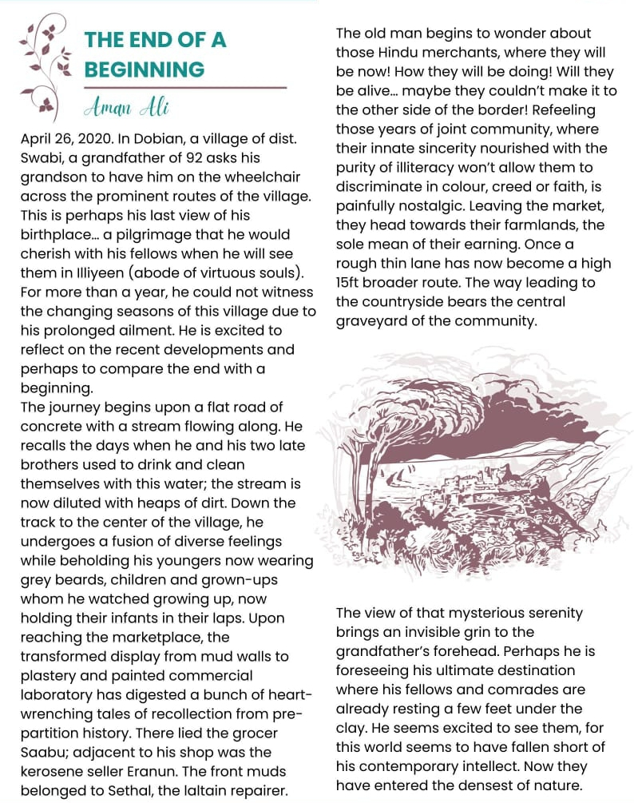

Appendix A: DECLARATION FORM

Please paste your
Photo here for
publication purpose

Title of composition:
Name:
IC No.:
Affiliated University/ Institute:

I (...................................................................................................................) ID No.:/ IC No.: (.........................................................................................) hereby confirm that the composition, with its illustrations, is my original work.

Signature: Date:
................................................................ ...............................................

Appendix B: AUTHOR’S INFORMATION

Full name of author: ________________________________________________
Institutional Affiliation: _____________________________________________
Contact number: ___________________________________________________
Email address: ____________________________________________________
About the author: ______________________________________________________________________________
______________________________________________________________________________
______________________________________________________________________________
______________________________________________________________________________
______________________________________________________________________________
______________________________________________________________________________
______________________________________________________________________________
______________________________________________________________________________
______________________________________________________________________________

