**OUTCOME ASSESSMENT AND IMPROVEMENT OF NORTH SINDH URBAN SERVICES CORPORATION’s (NSUSC) WATER SUPPLY PROJECTS: A CASE STUDY**



A thesis submitted by

1. **Mr. ………………………….. …EE…**
2. **Mr. ………………………….. …EE…**
3. **Mr. ………………………….. …EE…**
4. **Mr. ………………………….. …EE…**

In Partial fulfillment of the requirement for the degree of

**Bachelor of Engineering**

In

**Environmental Engineering**

Institute of Environmental Engineering & Management

Faculty of Architecture and Civil Engineering

Mehran University of Engineering & Technology, Jamshoro

Jamshoro

**February, 2017**

**DEDICATION**

**Once Sikandar-e-Azam & Arastu**

Once Sikandar-e-Azam and Arastu (his teacher) were going together

There was a deep river in way

Arastu decided to cross first and said: It’s not important that Arastu will die,

but it’s so important that Sikandar will survive

Because Sikandar is “The Need” of this world

Sikandar laughed, moved ahead and said:

It’s so important that Arastu will survive,

Because Sikandar cannot make Arastu, but Arastu can make many Sikandars

Dedicated to all Teachers

***The Best Teachers Teach From HEART, Not From Book.***

**Certificate**

**MEHRANUNIVERSITY OF ENGINEERING & TECHNOLOGY**

**JAMSHORO**

This is to certify that the work present in this on _____________________________ is entirely written by following students themselves under supervisor of _____________________ (Lecturer, Institute of Environmental Engineering & Management) and Engr. Azizullah Channa (Lecturer, Institute of Environmental Engineering & Management).

|  |  |  |
| --- | --- | --- |
| S.No | Name of Group Members | Roll Number |
| 1 | Mr. | 15EE |
| 2 | Mr. | 15EE |
| 3 | Mr. | 15EE |
| 4 | Mr. | 15EE |
| 5 | Mr. | 15EE |
| 6 | Mr. | 15EE |

|  |  |  |  |  |
| --- | --- | --- | --- | --- |
| **Supervisor**  Prof. Dr. Rasool Bux Mahar  PCAS-W, MUET Jasmhoro |  |  |  | **Co-Supervisor**  Dr. Abdul Razzaque Sahito  Institute of Environmental Engineering & Management |

|  |  |  |
| --- | --- | --- |
| **External Examiner**  Dr. Amanullah Mahar  Center for Environmental Science, University of Sindh |  | **Director**  Dr. Sheeraz Ahmed Memon  Institute of Environmental Engineering & Management |

Date: __________________

**Certificate**

**MEHRANUNIVERSITY OF ENGINEERING & TECHNOLOGY**

**JAMSHORO**

This is to certify that the work present in this on _____________________________ is entirely written by following students themselves under supervisor of _____________________ (Lecturer, Institute of Environmental Engineering & Management) and Engr. Azizullah Channa (Lecturer, Institute of Environmental Engineering & Management).

|  |  |  |
| --- | --- | --- |
| S.No | Name of Group Members | Roll Number |
| 1 | Mr. | 12EE |
| 2 | Mr. | 12EE |
| 3 | Mr. | 12EE |
| 4 | Mr. | 12EE |
| 5 | Mr. | 12EE |
| 6 | Mr. | 12EE |

|  |  |  |  |  |
| --- | --- | --- | --- | --- |
| **Supervisor**  Prof. Dr. Rasool Bux Mahar  PCAS-W, MUET Jasmhoro |  |  |  | **External Examiner**  Dr. Amanullah Mahar  Center for Environmental Science, University of Sindh |

|  |
| --- |
| **Director**  Dr. Sheeraz Ahmed Memon  Institute of Environmental Engineering & Management |

Date: __________________

**ACKNOWLEDGMENTS**

In the name of Allah the most merciful, all exalt to Allah for providing me courage, potency I have been able to complete my exposition successfully due to Allah continue blessings upon me.

It has been ever great experience to learn under the dynamic teaching expertise of Professor Dr. Khan Mohammad Brohi the Supervisor of my thesis and Prof. Dr. Sheeraz Ahmed Memon the Co-supervisor of my thesis. Their continuous and right guidance enabled me to keep high moral and meet the requirement up to the required standard, to be more specific and professional.

I am also thankful to Professor Dr. Khan Muhammad Brohi the Dean of faculty of Architecture and Civil Engineering, and the Director Institute of Environmental Engineering & Management, Dr. Sheeraz Ahmed Memon for consistent support throughout the career up-to the higher level of this study as being the student of Mehran University of Engineering & Technology, Environment department.

I am grateful to My Entire Family (My Father, My beloved Mother, My Brothers, & My Sister) for pushing me to bring this achievement at this level today. I am also great thankful to …………………………………. for friendly support and courage to complete my study.

Moral support of my beloved friends Mr. Faisal Ali Haroon Bhutto and Mr. Tallat Yasir Rajper encouraged me to finish my research goal in ME.

I am very much confident and keeping high hopes about my research work that I play my part to serve my nation.

**TABLE OF CONTENTS**

**DESCRIPTION Page**

**List of Figures vii**

**List of Tables ix**

**List of Abbreviations xi**

**Abstract xiii**

**CHAPTER 1 INTRODUCTION 1**

* 1. Introduction 1
  2. Background 2
  3. Problem Outcome 5
  4. ………………… ..

**CHAPTER 2 LITERATURE REVIEW 6**

2.1 Introduction 6

2.3 Project Scope Management 13

2.3.1 Plan Scope Management 13

2.3.6 Control Scope 23

2.4 Project Time Management 24

2.4.1 Plan Schedule Management 25

2.4.7 Control Schedule 39

2.5 Project Cost Management 42

2.5.3 Determine Budget 48

2.5.4 Control Costs 50

2.6 Project Quality Management 53

2.6.1 Plan Quality Management 56

2.6.3 Control Quality 60

2.7 Project Procurement Management 62

2.7.1 Plan Procurement Management 62

………………………………………

**CHAPTER 3 METHODOLOGY 70**

3.1 Quantitative (Positivism) 70

3.3.3 Unstructured Interviews 71

3.4 Exploratory Research 72

3.8 Methodology for Objective 2 74

**CHAPTER 4 RESULTS AND DISCUSSION 75**

4.1 Data Collection for Objective 1 75

4.1.1 Project’s Findings/Shortcomings 86

during Assessment in Objective 1

4.2 Data Collection for Objective 2 87

4.2.1 Aim of Projects and Project 87

Components

4.2.2 Water Quality Targets 106

4.2.3 Questionnaire Survey 111

4.3 Project Findings/Shortcomings During 113 Assessment in Objective 2

4.4 Data Collection for Objective 3 114

4.4.1 Expert Opinion 1 114

4.4.1.1 For ICB 3 and 4 114

4.4.1.2 For Upcoming Projects 116

**CHAPTER 5 CONCLUSION AND SUGGESTIONS 122**

5.1 Conclusion 122

5.2 Suggestions 122

5.3 Suggestions 123

**REFERENCES 125**

**LIST OF FIGURES**

Figure: 2.1 Layout of typical water treatment plant (rapid sand filter) 9

Figure: 4.1 Sign Board of ICB 3 Bunder Road Water Treatment Plant 90

Sukkur

Figure: 4.2 Alum Mixing Chamber (outside) Bunder Road Water Treatment 90 Plant Sukkur

Figure: 4.3 Alum Mixing Chamber inside Bunder Road Water Treatment 91

Plant Sukkur

Figure: 4.4 Flocculation Baffle Channels Bunder Road Water Treatment 91

Plant Sukkur

Figure: 4.5 Rehabilitated Laboratory Bunder Road Water Treatment 92

Plant Sukkur

Figure: 4.6 Sedimentation Tanks Bunder Road Water Treatment Plant 92

Sukkur

Figure: 4.7 Rehabilitated Ponds Numaish Water Treatment Plant Sukkur 95

**LIST OF TABLES**

Table 1.1 Details of Infrastructure Investments for ICB Single Package 3

Table 2.1 Comparison between Slow Sand Filter and Rapid Sand Filter 8

Table 2.2 Processes Involved in PM Knowledge Areas in overall Life 12

of Project Cycle

Table 3.1 Interview Questions as per PM Knowledge Areas for 73

Objective 1

Table 4.1 Response from concerned for Project Scope Management; 76

Project 1: Rehabilitation of 3 Water Treatment Plants

Table 4.2 Response from concerned for Project Scope Management; 77

Project 2: Improvement of Water Supply System in Selected Distribution Network Improvement (DNI) Zones (ICB 4)

Table 4.3 Response from concerned for Project Time Management; 78

Project 1: Rehabilitation of 3 Water Treatment Plants

Table 4.4 Response from concerned for Project Time Management; 79

Project 2: Improvement of Water Supply System in Selected Distribution Network Improvement (DNI) Zones (ICB 4)

**LIST OF ABBREVIATIONS**

ADB: Asian Development Bank

ADR: Alternate Dispute Resolution

BOD: Board of Directors

BOQ: Bill of Quantities

CCM: Critical Chain Method

NSUSC: North Sindh Urban Services Corporations Limited

OPA: Organizational Process Assets

PDM: Precedence Diagramming Method

PND: Project Network Diagramming

WTP: Water Treatment Plant

**ABSTRACT**

Asian Development Bank (ADB) injected investment to improve municipal services of secondary cities of North Sindh (Sukkur, Rohri, Khairpur, Shikarpur and Larkana). In order to achieve the objective, an autonomous organization NSUSC (North Sindh Urban Services Corporations) was formed by Government of Sindh and ADB under company ordinance 1984. The purpose was to plan and execute the investment in solid waste, wastewater and water supply sectors of northern cluster of Sindh. In 2010 NSUSC executed water supply projects by which rehabilitation work of three water treatment plants and six water supply Distribution Network Improvement (DNI) zones was executed. A case study of these projects is carried out through qualitative research method. Interviews were taken from clients, consultants and contractors to assess above projects in context of important project management knowledge areas. Project was also assessed in context of planned and actual outcome. The results reveal that one out of three water treatment plants was operational. Besides this, two out of six DNI zones were observed as fully operational. The study also identifies few flaws in planning, execution and monitoring phases of projects. On the basis of findings, expert opinions were taken to work out measures for improvement in the outcome of future projects of similar nature.

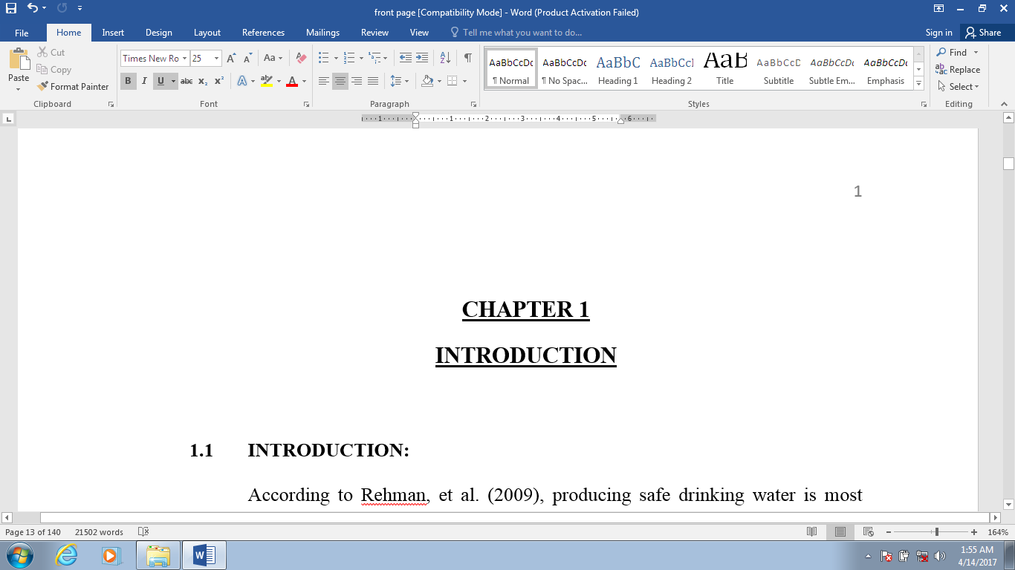**CHAPTER 1**

**INTRODUCTION**

* 1. **INTRODUCTION:**

According to Rehman, et al. (2009), producing safe drinking water is most challenging job that municipalities need to deal with limited resources. Study of water during supply of drinking water.

Foreign Direct Investment (FDI) by donor agencies is key source for developing countries to improve condition of essential municipal services. Unfortunately secondary cities of Sindh were ignored in past decades regarding to

The North Sindh Urban Services Corporation (NSUSC) has been established in year 2010 under the companies’ ordinance 1984 for improving essential municipal Rehabilitation of 3 WTPs in sukkur and khairpur; International Contract Bidding 3 (ICB-3).

1. Installation and commissioning of DNI (distribution network improvement) zones in sukkur, khairpur and rohri cities; International Contract Bidding 4 (ICB-4). The aim of this study is to assess outcome of projects which is launched by NSUSC under its own guidelines and make recommendations for improved measures.
   1. **BACKGROUND**

According to inception report of Michael Chapman (2010), Sindh Cities Improvement Investment Program (SCIP) is a program to improve basic urban infrastructure in Sindh's secondary towns through priority investment in water supply,

**Table 1.1: Details of Infrastructure Investments for ICB Single Package**

|  |  |
| --- | --- |
| **Sukkur and New Sukkur Water Supply** | |
| 1 | **Rehabilitation of Bunder Road treatment plant**—Install new Chemical dosing plant, mixing and flocculation tanks, rehabilitation of structures, replacement of filter media, replacement of indicators and gauges, fixing leaks around the 5 million gallons per day (MGD) capacity water treatment plant, installation of *salt* chlorination equipment. |
| 2 | **Rehabilitation of Numaish treatment plant**—Install new Chemical dosing equipment, mixing and flocculation tanks, rehabilitation of structures, replacement of filter media, replacement of indicators and gauges, fixing leaks around the 2.5 MGD capacity water treatment plant, desludging of sedimentation tanks, desilting *of settlement ponds*, provision of geomembrane, alum dosing and chlorination equipment. |
| 3 | **Two distribution network improvement (DNI) zones (Sukkur):** Replacement of distribution network, household connections, installation of domestic and commercial meters and associated investment in transmission lines. Designed to provide 6,000 customers with 24/7 potable water supply. |

* 1. **RESEARCH JUSTIFICATION**

Pakistan is one of the developing countries and service delivery status of municipal services is worst especially in secondary cities. It was observed that some

* 1. **OBJECTIVES OF STUDY**

Main objectives of this study are:

1. To assess the NSUSC projects in Sindh in context of important project management (PM) knowledge areas; i-e Cost, Time, Quality, Scope,
   1. **SCOPE OF THE STUDY**

Scope of project is to make benchmarks by which it can make planning in better way for upcoming investments. The focus is to reviewing rehabilitation of 3

**1.6 RESEARCH SIGNIFICANCE**

Usually foreign investors focus on successful completion of projects up to end user. Impact of such efficiency will encourage future investments. Results of this

**1.7 PROBLEM OUTCOME**

By addressing issues related to project management we can acquire higher ratio of success in project deliverables. This study focuses importance of

**CHAPTER 2**

**LITERATURE REVIEW**

**2.1 INTRODUCTION:**

According to Azenić, et al. (2002), supplying safe drinking water is complex system which is very important in our society. Improvement of water supply methods population may face serious water shortage by year 2050.



**Figure 2.1: Layout of typical water treatment plant (rapid sand filter)**

As per Liu et al. (2013), water management is challenging job due to many produce drinking water at sustainable pressure at domestic nodes.

**CHAPTER 3**

**METHODOLOGY**

Kothari (2004) defines the following types of researches;

**3.1 QUANTITATIVE (POSITIVISM):**

* Ask the people about reality through **questionnaire**; hypothesis (try to ask people).
* Take people as case, make survey and distribute.
* Conceptual model; this research method based on concept – concept relationship.

**3.2 QUALITATIVE (INTERPRETIVE):**

* A **case study** research method.
* Truth is different from company to company. Reality is different from place to place, country to country.
* Describing problem in words.
* Observing organizational structure; how people behave, what is the process, how process can be managed, what is the methodology for managing this, what is the tool, how to increase performance of people.
* Try to find the solution.
* Collection of data through **interviews** (structured, semi structured or unstructured).

Our research methodology in “**OUTCOME ASSESSMENT AND IMPROVEMENT OF NORTH SINDH URBAN SERVICES CORPORATION’s (NSUSC) WATER SUPPLY PROJECTS: A CASE STUDY**” will be ***qualitative study***. Research interviews will be used to collect data;

**3.3 RESEARCH INTERVIEWS:**

The research interview is a purposely conversation between two or more people, requiring the interviews to establish the report, to as concise and unambiguous questions, to which the interviewer is willing to respond, and listen attentively.

* + 1. **Structured Interviews**:

These are very standardized interviews. These are fixed standardized questions in predetermined order and nothing will change and will ask all these questions and record the interview answers.

* + 1. **Semi structured Interviews**:

In this case we are not fixed the questions and order of questions can be changed, may be add some questions if we during interview find out that particular topic is very interesting.

* + 1. **Unstructured Interviews**:

Free conversation. Let the person to freely talk on specific topic.

Which type of interview is suitable for particular research? Here are selection criteria for selecting interview type for particular research work;

**CHAPTER 4**

**DATA COLLECTION AND ANALYSIS**

**4.1 DATA COLLECTION FOR OBJECTIVE 1**

As per objective 1 of research work, structured interviews were conducted to assess the NSUSC projects in context of important project management knowledge areas.

**NSUSC Project Names:**

1. Rehabilitation of 3 Water Treatment Plants (ICB-3)
2. Improvement of Water Supply System in selected Distribution Network Improvement (DNI) zones (ICB-4)

Five structured interviews were conducted for assessing above projects in context of PM knowledge areas, two interviewees from client, one interviewee from consultants and two interviewees from contractor’s side. Response from concerned in accordance to questionnaire was as following;

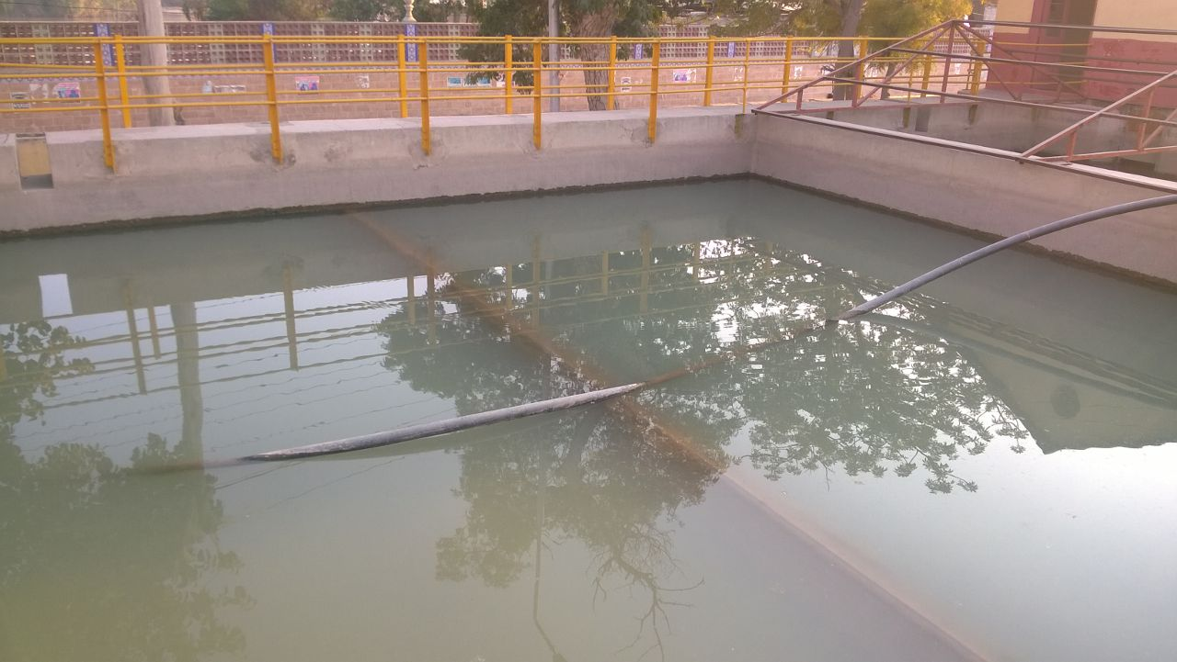

**Fig: 4.6: Sedimentation Tanks Bunder Road Water Treatment Plant Sukkur**

**CHAPTER 5**

**CONCLUSION AND SUGGESTIONS**

* 1. **INTRODUCTION**

This chapter presents conclusions and recommendations on the basis of findings of NSUSC water supply projects, which may help to make more beneficiary upcoming investments. The main objective of study is to assess NSUSC projects in context of PM knowledge areas and to work out measures for improvement in the outcome of future projects.

* 1. **CONCLUSIONS**

After detailed study of NSUSC water supply projects in context of project management knowledge areas and outcome assessment, it is concluded that there was genuine need of rehabilitation work in water supply sector in northern cluster of Sindh. Asian Development Bank (ADB) injected heavy investment to provide safe treated drinking water facilities through rehabilitation of three water treatment plants and installation of Distribution Network Improvement (DNI) zones in Sukkur, Rohri and Khairpur.

Based on detailed analysis it was found that ICB-3 project increased the production of raw water after installation of new assets but treatment facility could not be made fully operational in two water treatment plants of Sukkur. Situation is different in Khairpur where slow sand gravity filter plant was made operational and water quality was increased as per international standards. On the other hand, treatment facility at Bunder Road and Numaish Water Treatment Plants in Sukkur was not fully operational. The main reason behind poor operational status of treatment plants as identified in this study was lack of planning and monitoring.

In second project total six DNI zones were planned to install in Sukkur, Rohri and Khairpur. Aim of DNI zones was to provide safe treated drinking water to end users at sufficient pressure round a clock. It was planned that four out of six DNI zones will get water from future project (ICB-5) and two out of six DNI zones will be feed from rehabilitated Khaki Shah Water Treatment Plant. Study concluded that ICB-5 project could not be started till yet resulting four DNI zones as not fully operational. Two DNI zones are beneficiary for end users due to operational conditional of feeding source i-e Khaki Shah Water Treatment Plant, Khairpur.

**REFERENCES**

[1] Dick, W.; Carey, L.; and Carey, J.O. (1996), *A guide to the project management body of knowledge (PMBOK® Guide) Development*,2, No. 2.1,pp.2-2.

[2] Azizullah, A.; Khattak, M. N. K.; Richter, P.; & Häder, D. P. (2011), "Water pollution in Pakistan and its impact on public health—a review," *Environment International.* V.37, No. 2, 2011, pp. 479-497.

[3] Bekker, M. C. (2004), "Defining a project life-cycle for implementing a high-tech project in rural Southern Africa-a case study," *AFRICON, 7th AFRICON Conference, in Africa*, IEEE, V. II, pp. 873-877